<https://www.youtube.com/watch?v=JQc3yx0-Q9E&list=PLblh5JKOoLUK0FLuzwntyYI10UQFUhsY9&index=11>

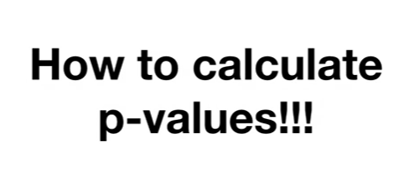

Today we're gonna talk about how to calculate p-values.

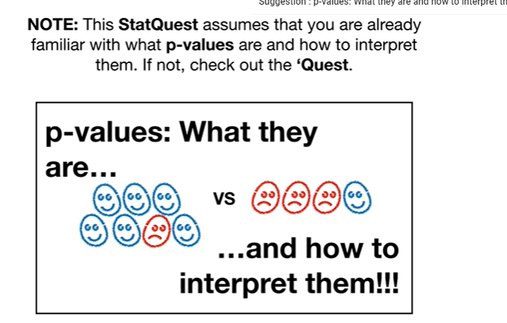

Note : this stat quest assumes that you are already familiar with what p-values are and how to interpret them if not check out the quest.



Also note : before we get started I want to mention that there are two types of P values

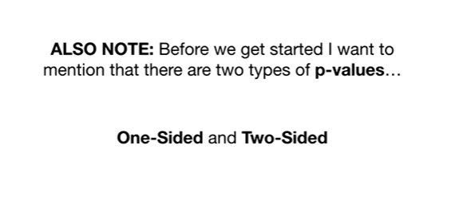

one sided and two sided.

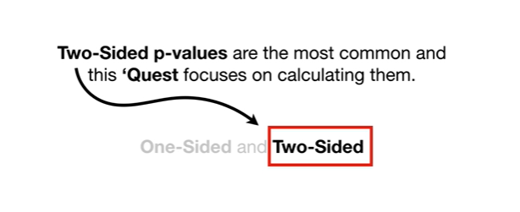

Two-sided p-values are the most common and this quest focuses on calculating them.

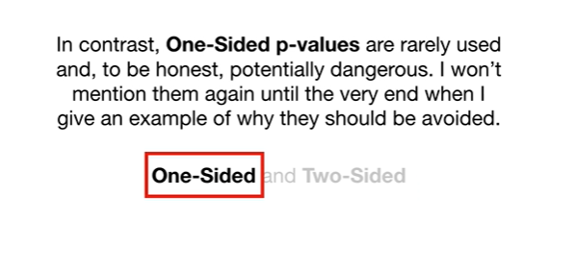

In contrast one-sided p-values are rarely used and to be honest potentially dangerous I won't mention them again until the very end when I give an example of why they should be avoided.

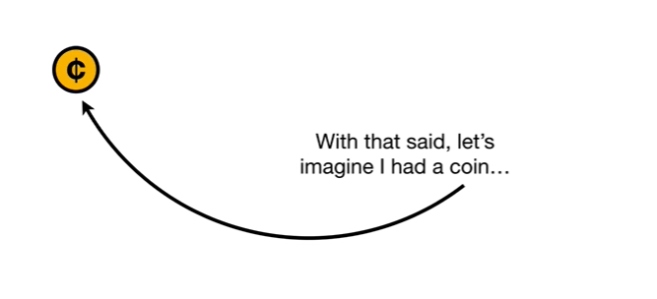

With that said let's imagine I had a coin

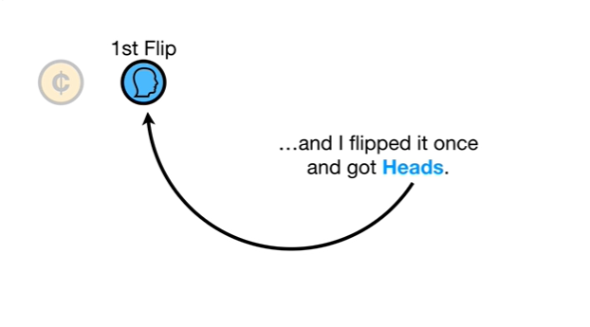

and I flipped it once and got heads.

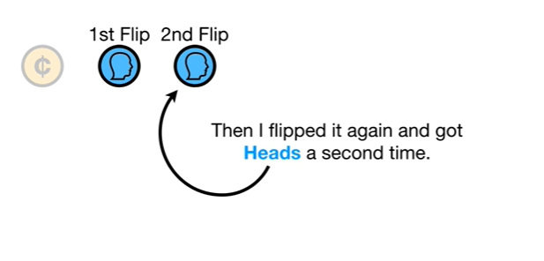

Then I flipped it again and got heads a second time.



Now at this point I might be tempted to think wow !

My coin is super special because it landed on heads twice in a row !!

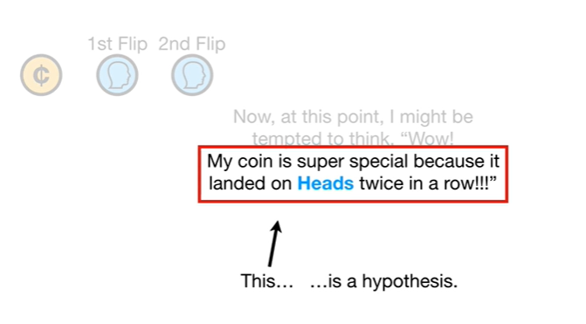

This is a hypothesis.

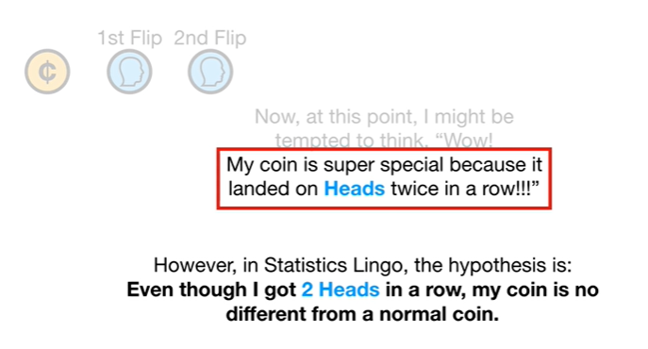

However in statistics lingo the hypothesis is : even though I got two heads in a row, my coin is no different from a normal coin.

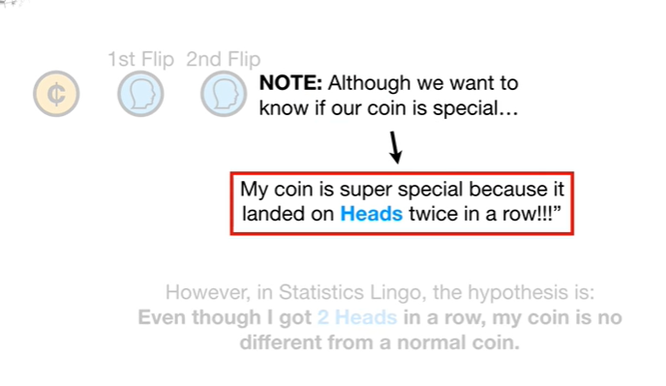

Note : although we want to know if our coin is special

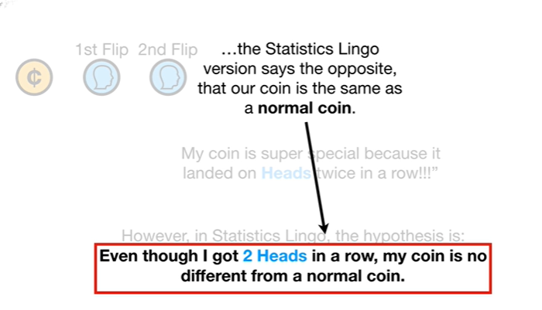

the statistics lingo version says the opposite, that our coin is the same as a normal coin.

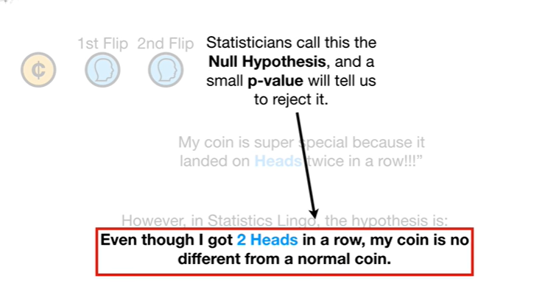

Statisticians call this the null hypothesis and a small p-value will tell us to reject it.

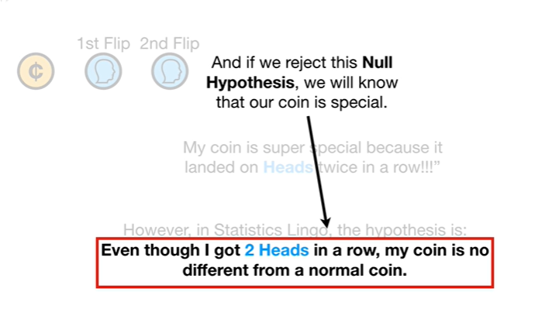

And if we reject this null hypothesis we will know that our coin is special.

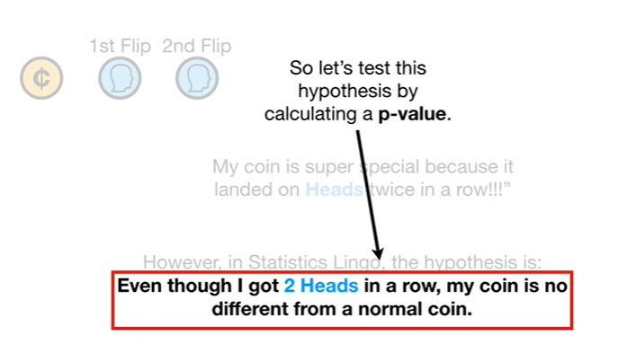

So let's test this hypothesis by calculating a p-value.

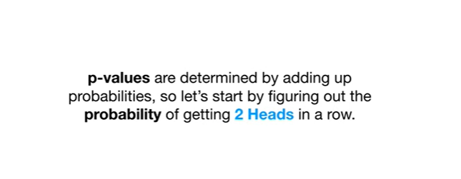

p-values are determined by adding up probabilities so let's start by figuring out the probability of getting two heads in a row.

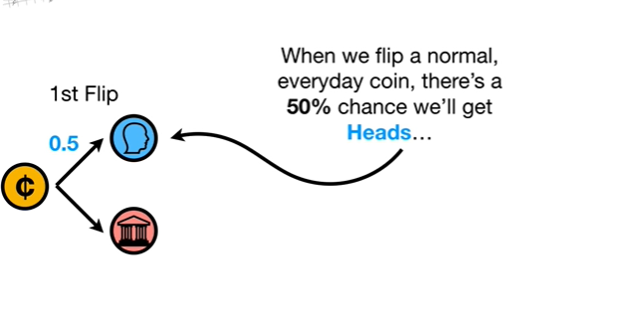

When we flip a normal everyday coin there's a 50% chance we'll get heads

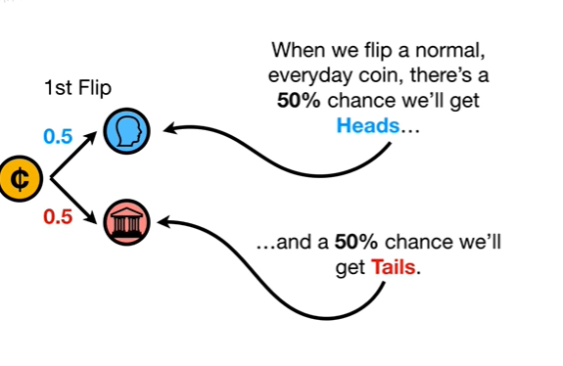

and a 50% chance we'll get tails.



Now if we got heads on the first flip

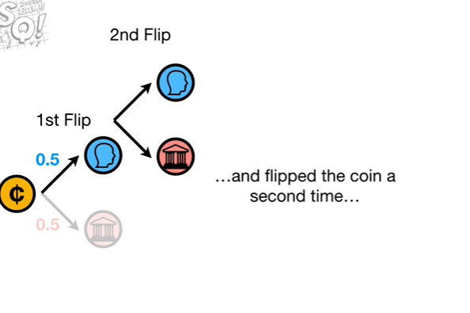

and flip the coin a second time

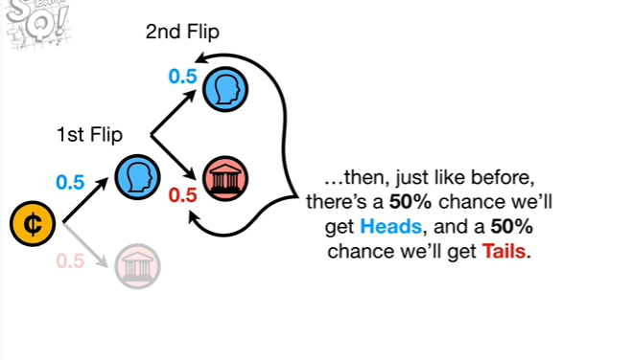

then just like before there's a 50% chance we'll get heads and a 50% chance we'll get tails.

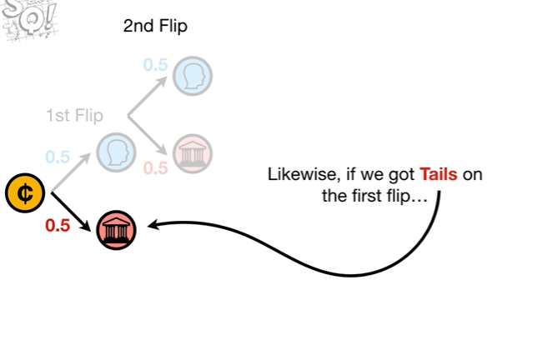

Likewise if we got tails on the first flip

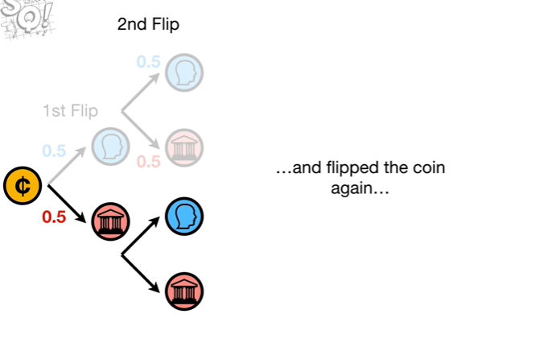

and flip the coin again

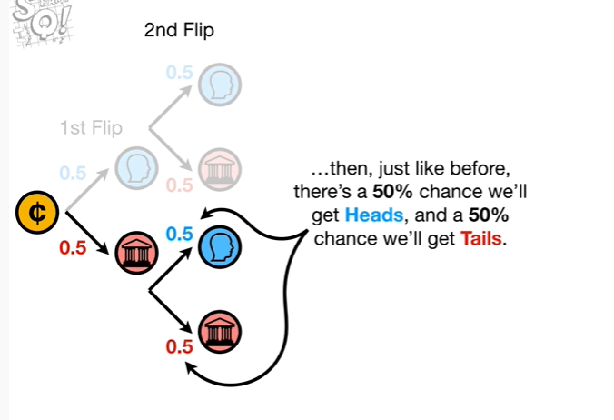

then just like before there's a 50% chance we'll get heads and a 50% chance we'll get tails.

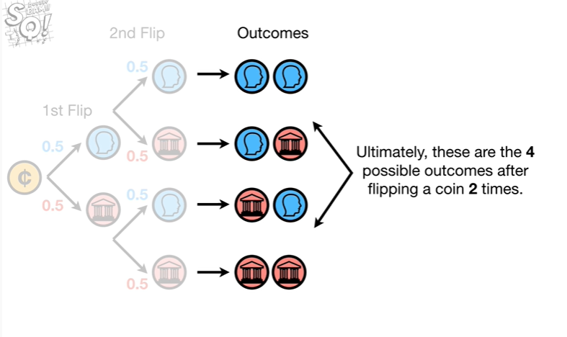

Ultimately these are the four possible outcomes after flipping a coin two times.

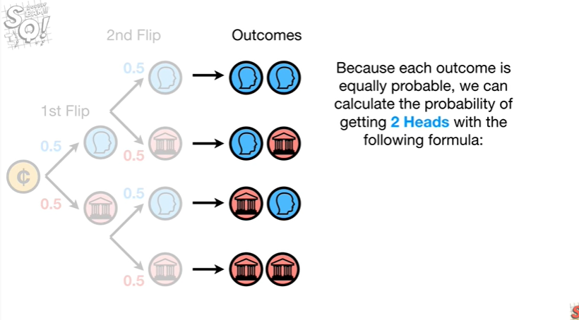

Because each outcome is equally probable we can calculate the probability of getting two heads with the following formula :

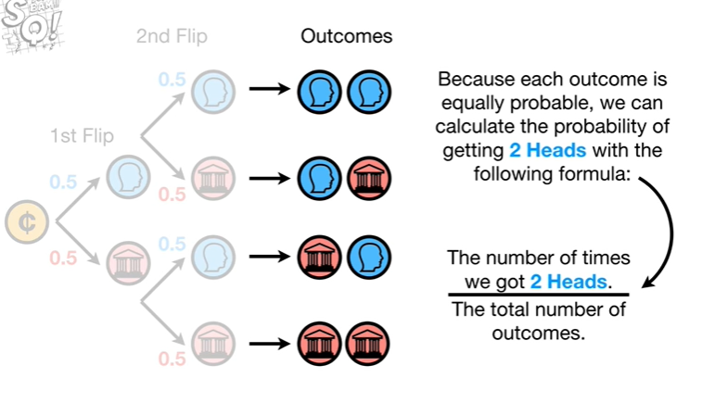

the number of times we got two heads divided by the total number of outcomes.

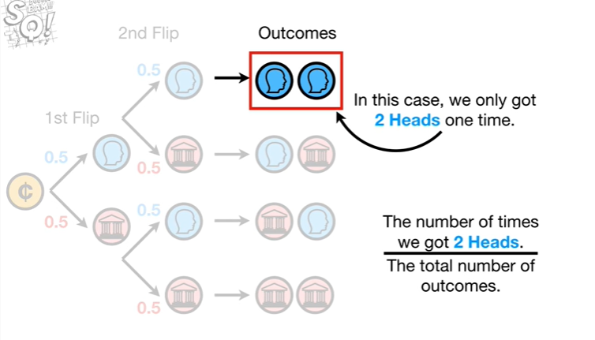

In this case we only got two heads one time so we put a 1 in the numerator.

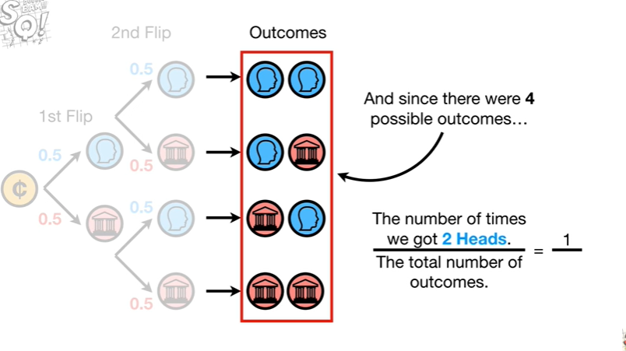

And since there were four possible outcomes we put a four in the denominator.

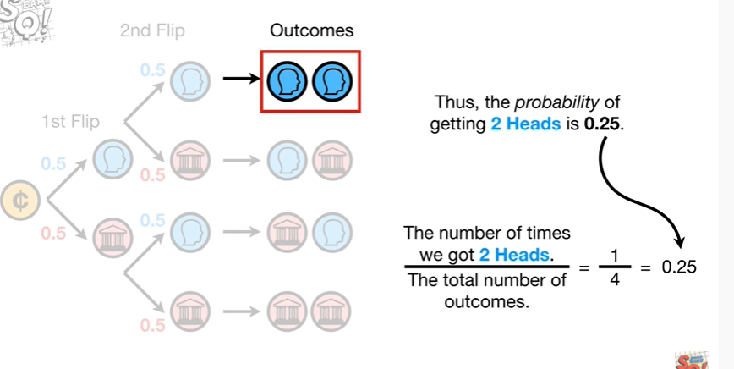

Thus the probability of getting two heads is 0.25.

L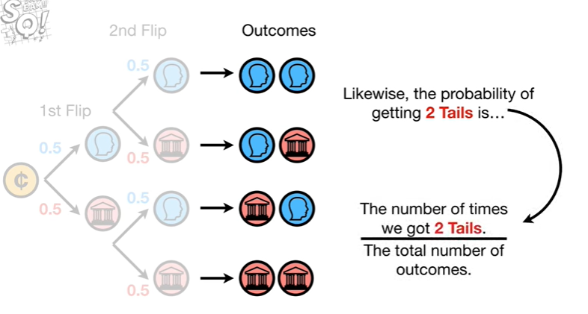Likewise the probability of getting two tails is

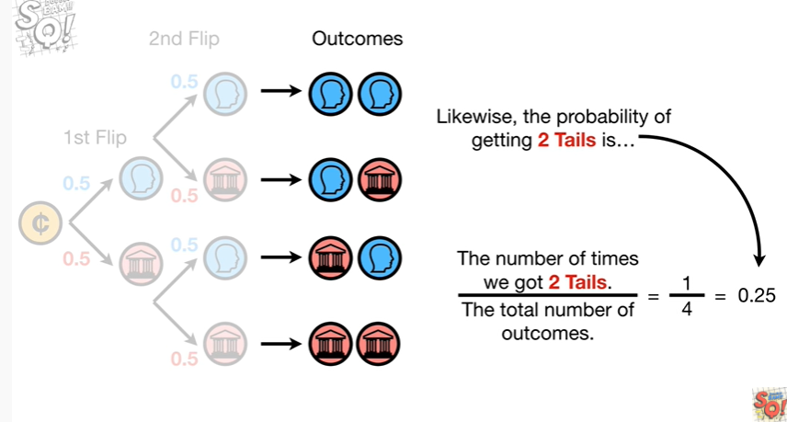

0.25.

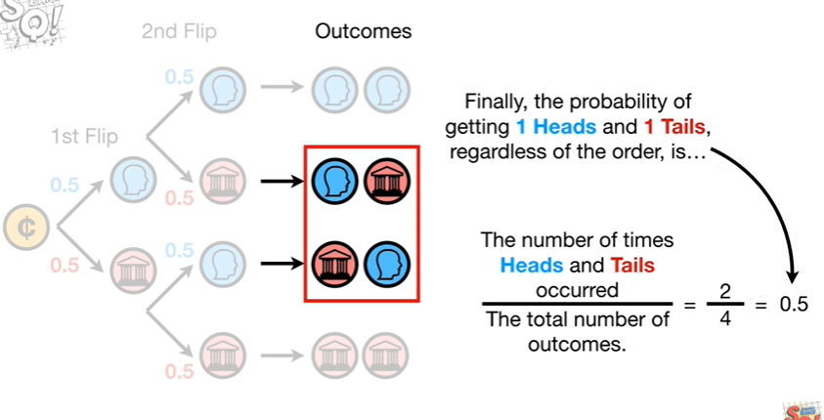

Finally the probability of getting one heads and one tails regardless of the order is 0.5.

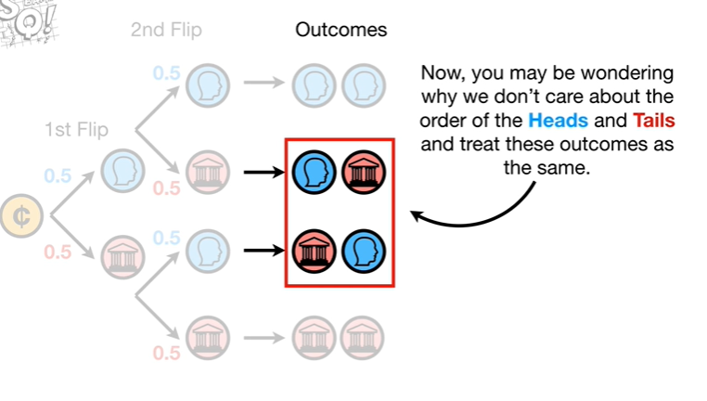

Now you may be wondering why we don't care about the order of the heads and tails and treat these outcomes as the same.

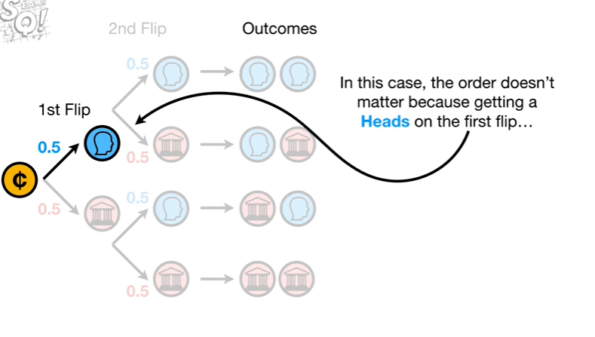

In this case the order doesn't matter because getting a heads on the first flip

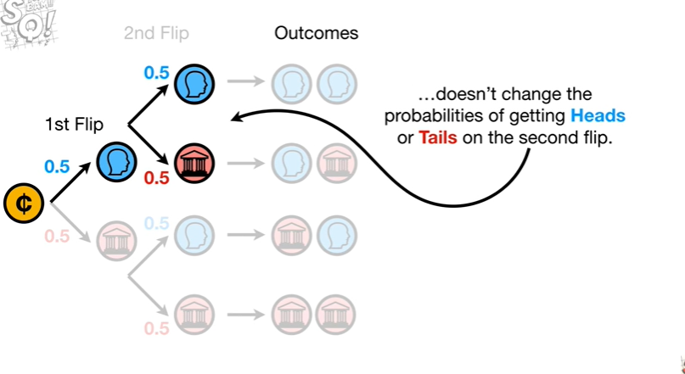

doesn't change the probabilities of getting heads or tails on the second flip.

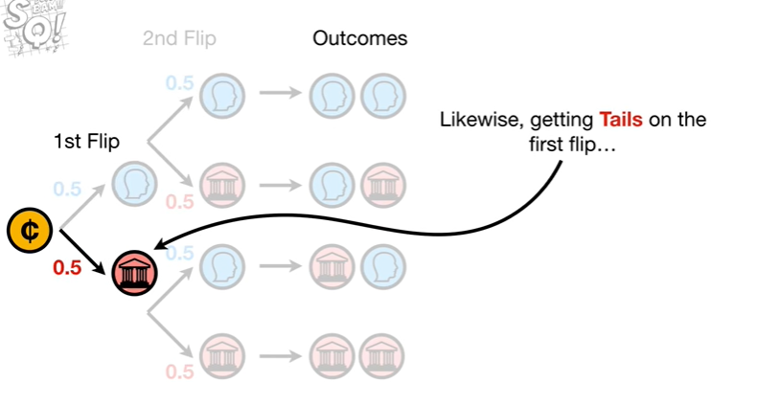

Likewise getting tails on the first flip

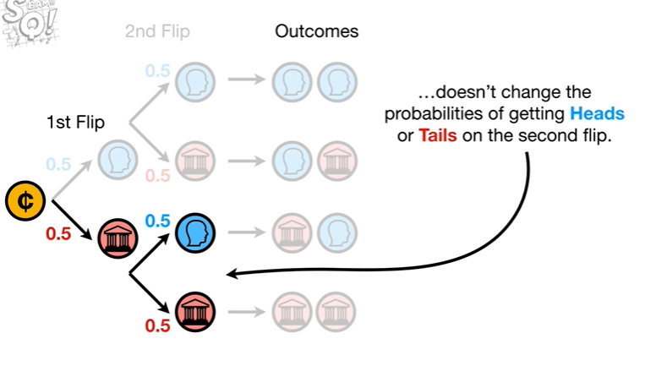

doesn't change the probabilities of getting heads or tails on the second flip.

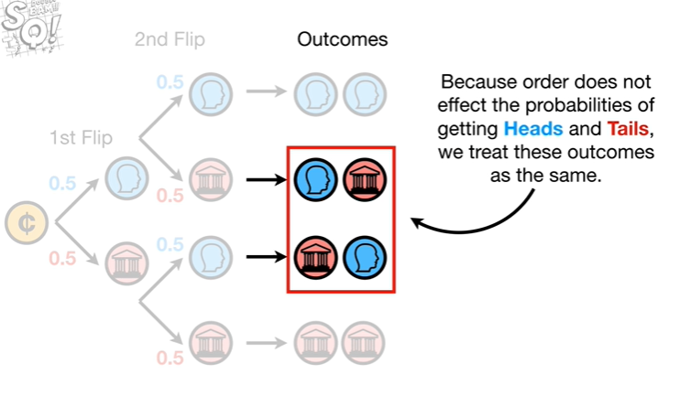

Because order does not affect the probabilities of getting heads and tails we treat these outcomes as the same.

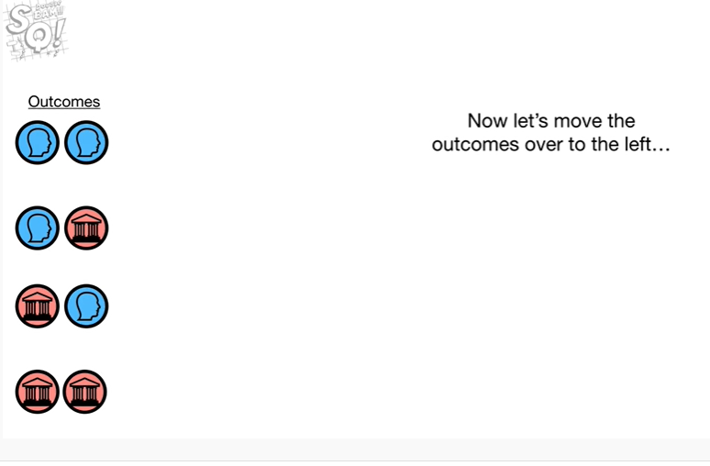

Now let's move the outcomes over to the left unless the probability of each outcome

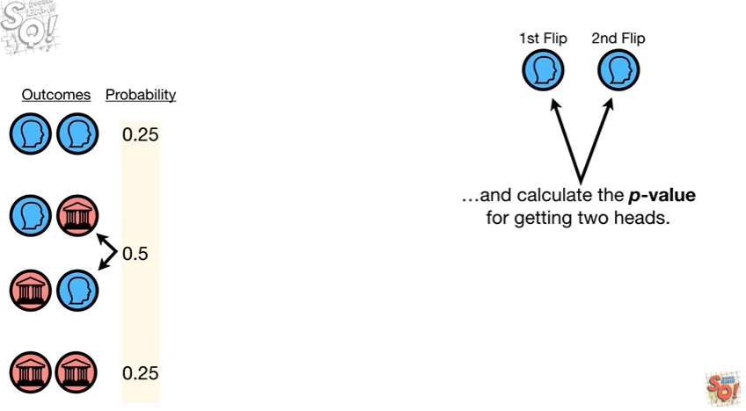

and calculate the p-value for getting two heads.

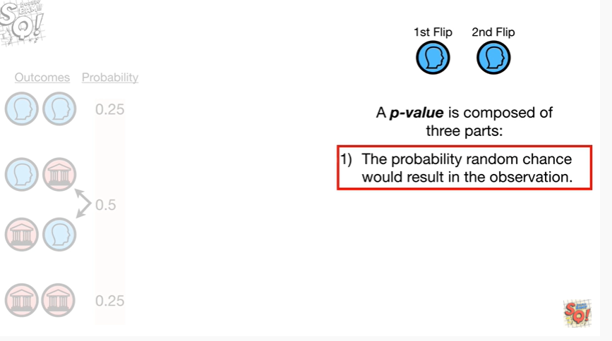

A p-value is composed of three parts.

The first part is the probability random chance would result in the observation.

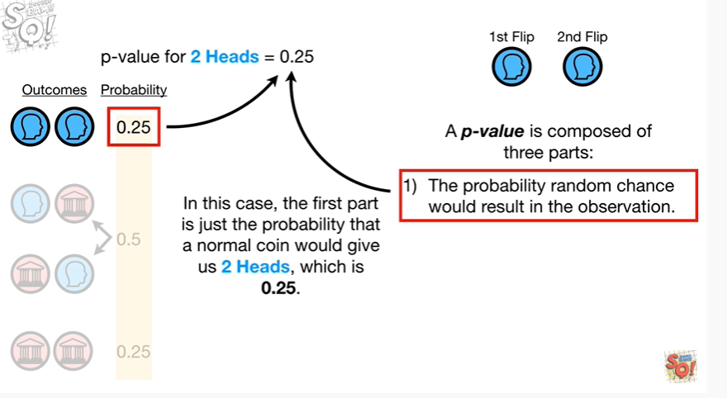

In this case the first part is just the probability that a normal coin would give us two heads which is 0.25.

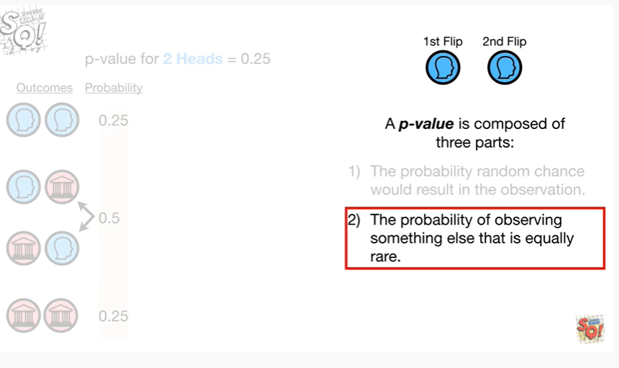

The second part is the probability of observing something else that is equally rare.

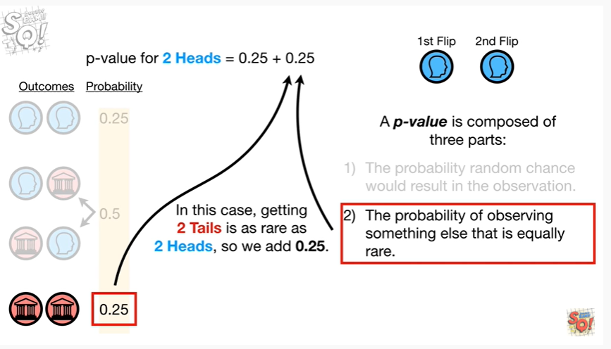

In this case getting two tails is as rare as two heads so we add 0.25.

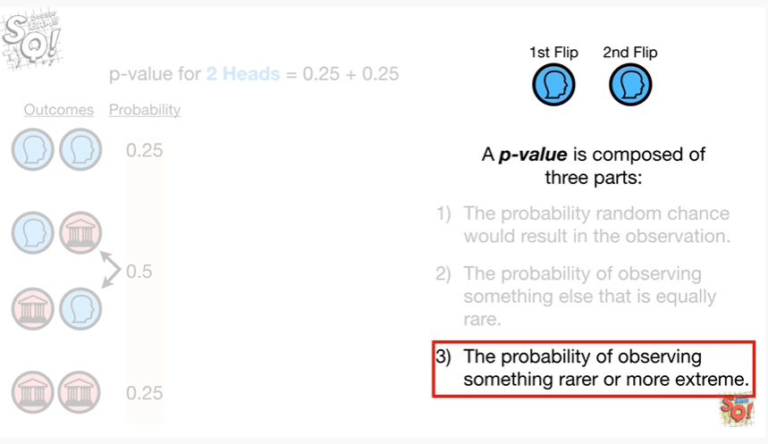

The third part is the probability of observing something rare or more extreme.

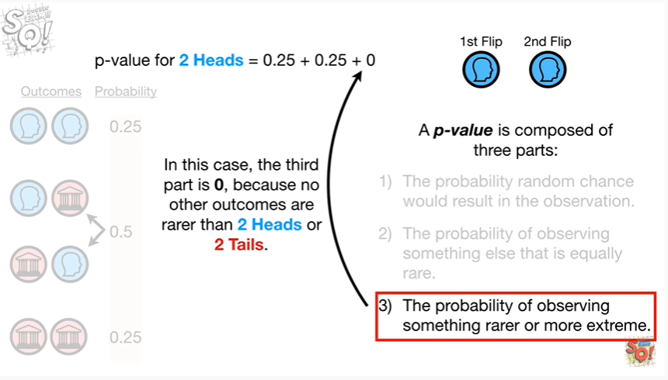

In this case the third part is zero because no other outcomes are rarer than two heads or two tails.

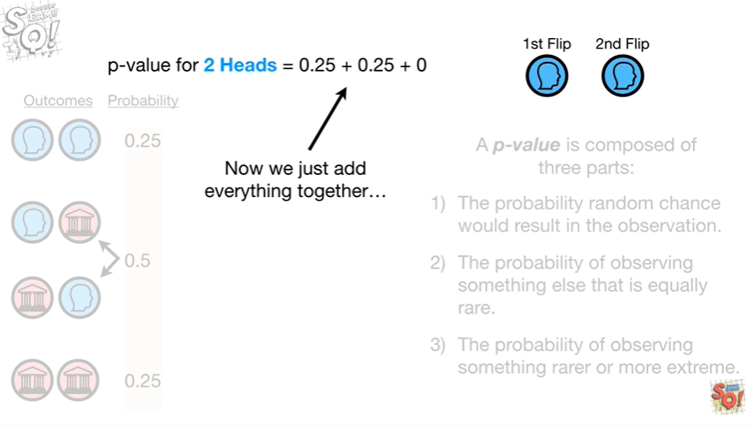

Now we just add everything together

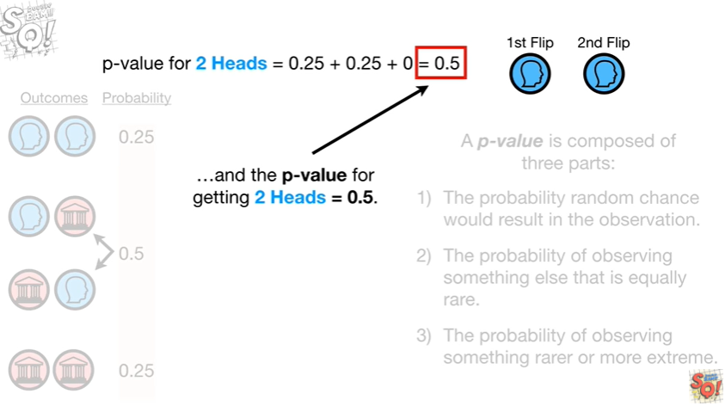

and the p-value for getting two heads equals 0.5.

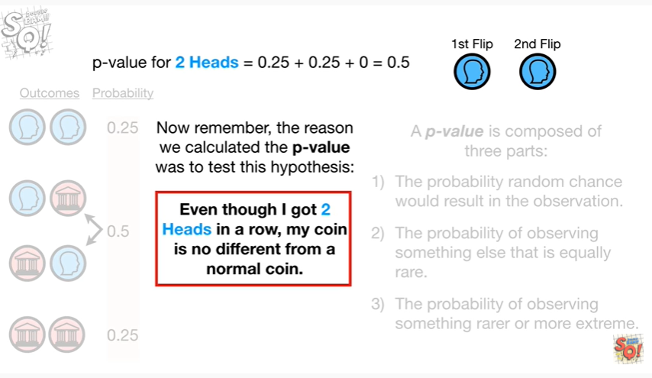

Now remember the reason we calculated the p-value was to test this hypothesis : even though I got two heads in a row my coin is no different from a normal coin.

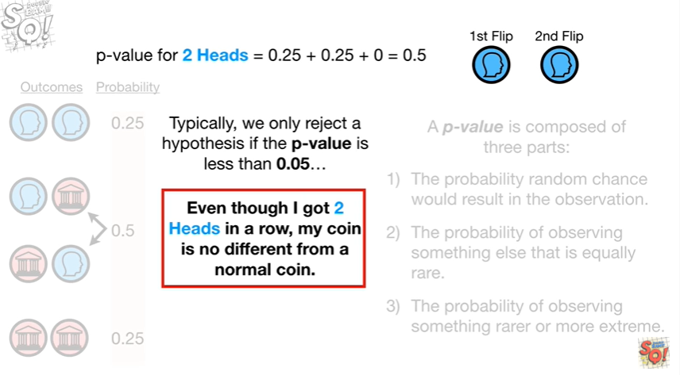

Typically we only reject a hypothesis if the p-value is less than 0.05

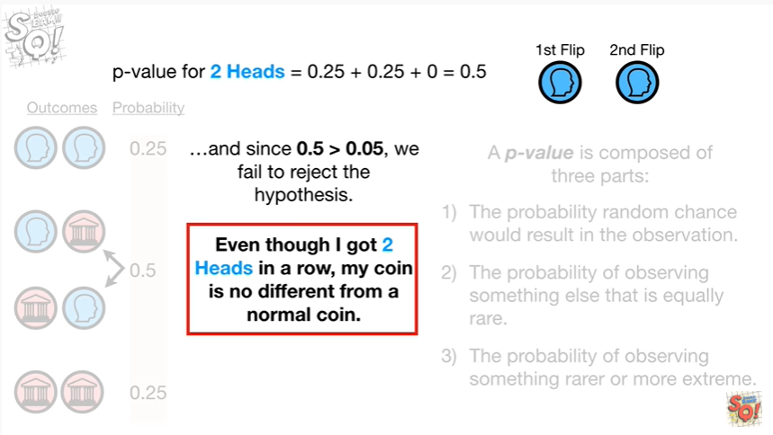

and since 0.5 is greater than 0.05 we fail to reject the hypothesis.

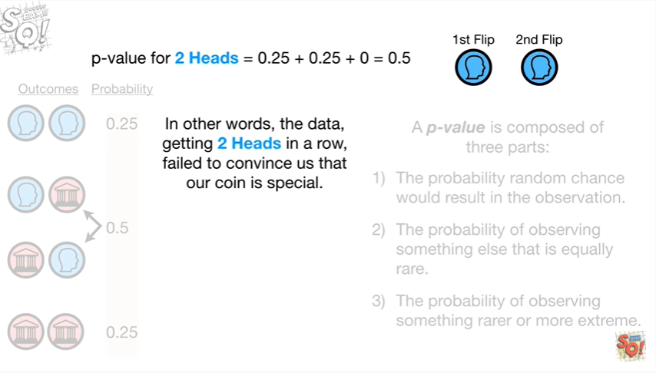

In other words the data getting two heads in a row, failed to convince us that our coin is special.

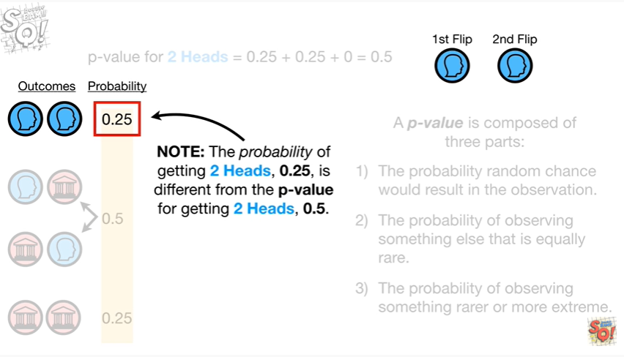

Note : the probability of getting two heads 0.25 is different from the p-value for getting two heads 0.5.

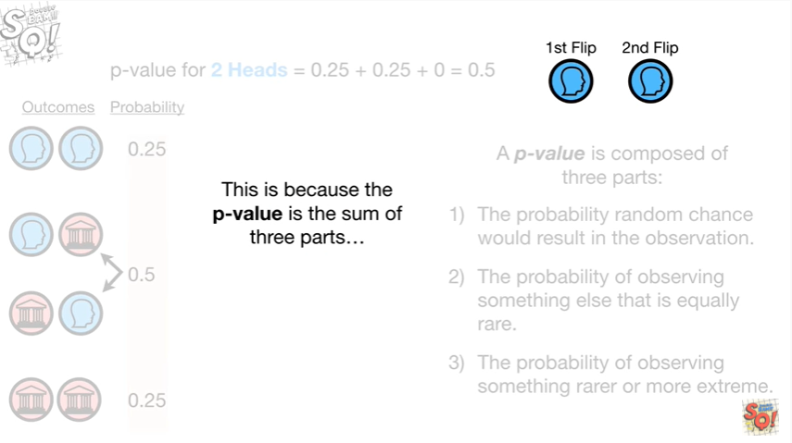

This is because the p-value is the sum of three parts

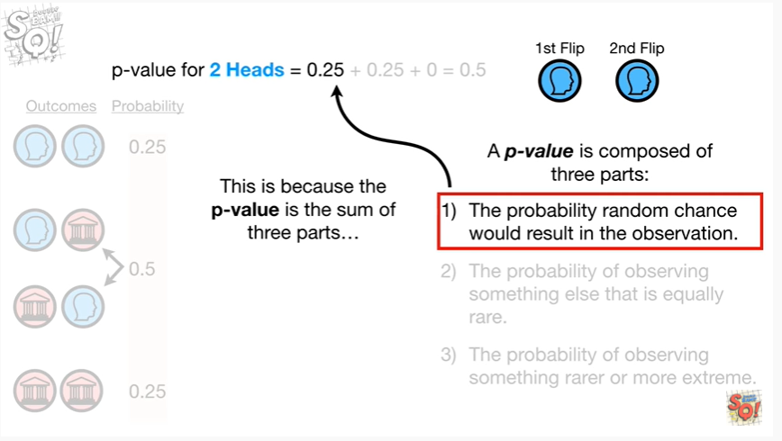

the first part is the probability random chance would result in the observation

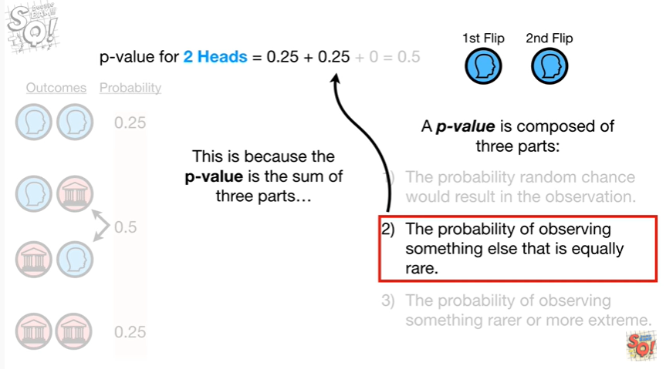

the second part is the probability of observing something else that is equally rare.

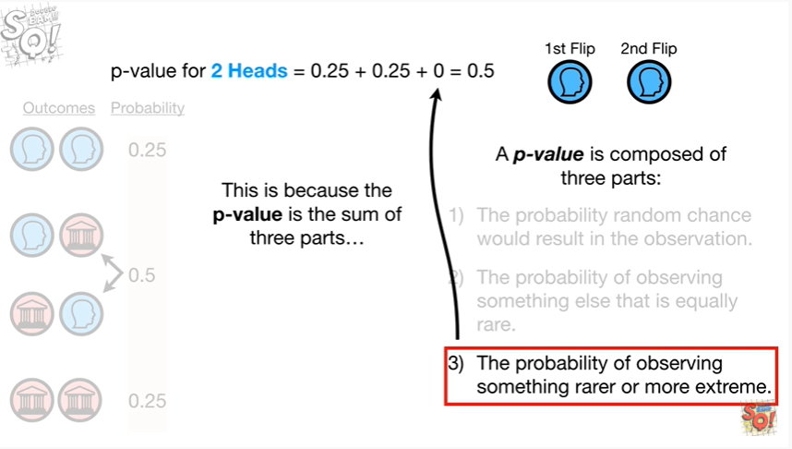

And the third part is the probability of observing something rare or more extreme.

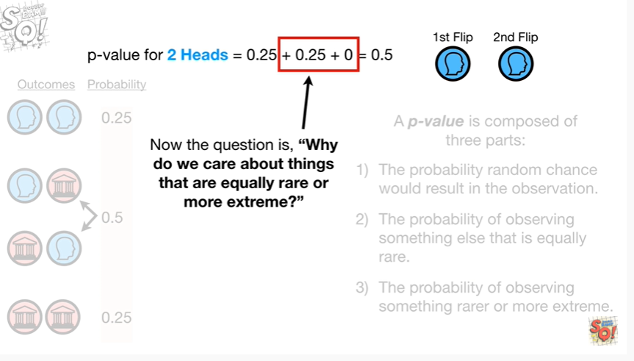

Now the question is why do we care about things that are equally rare or more extreme ?

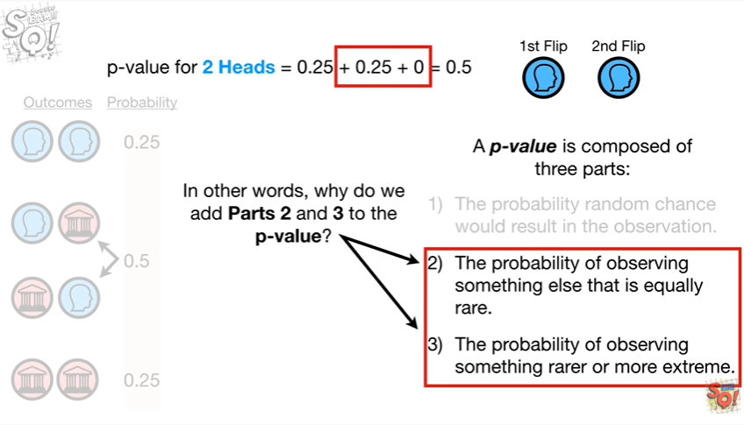

In other words why do we add parts two and three to the p value ?

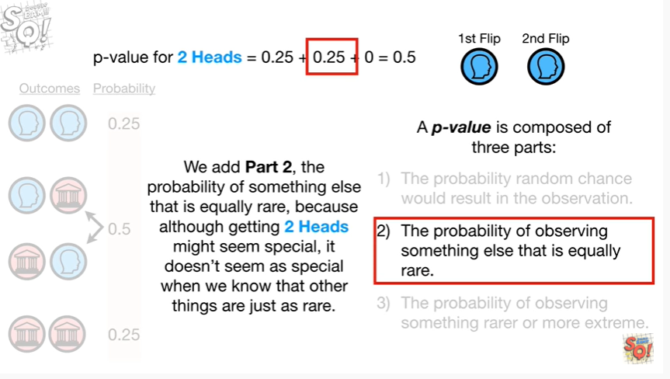

We add part to the probability of something else that is equally rare because although getting two heads might seem special it doesn't seem as special when we know that other things are just as rare.

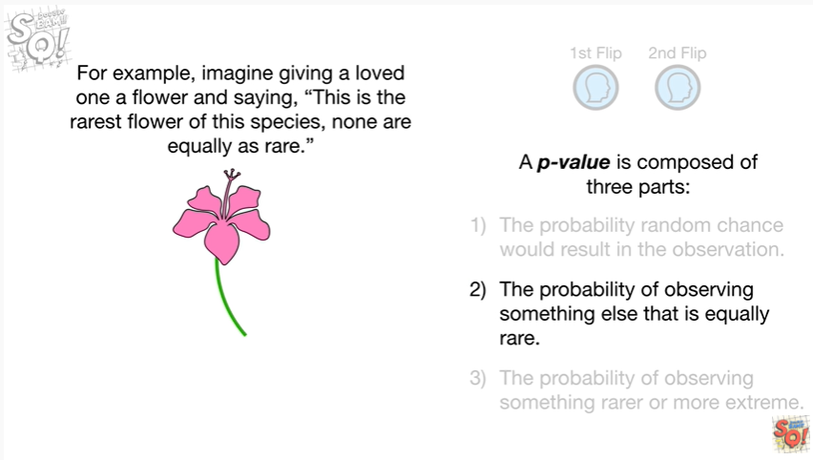

For example imagine giving a loved one a flower and saying this is the rarest flower of this species none are equally as rare.

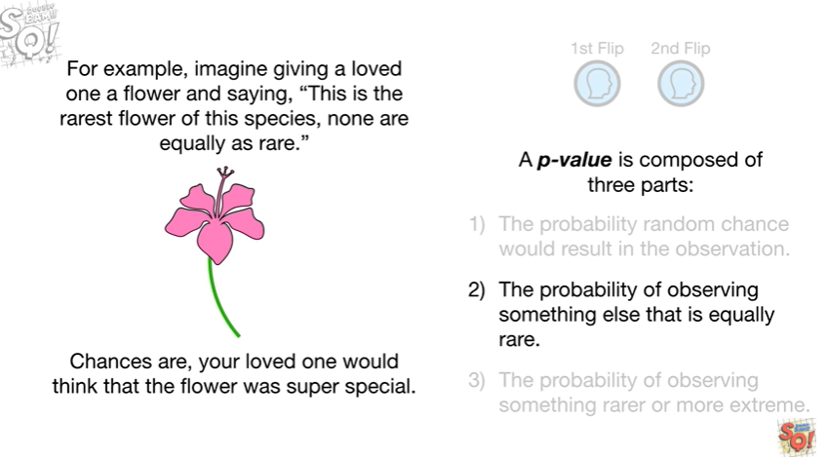

Chances are your loved one would think that the flower was super special.

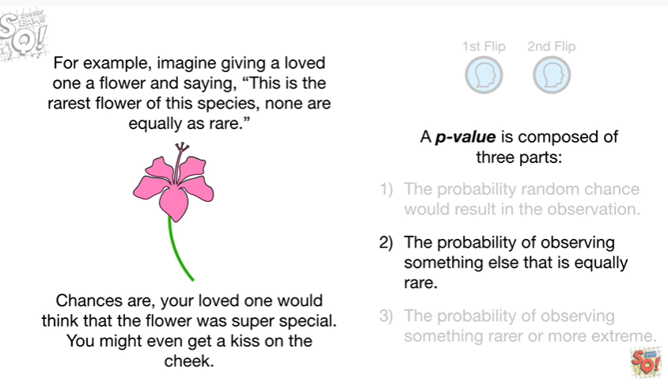

You might even get a kiss on the cheek.

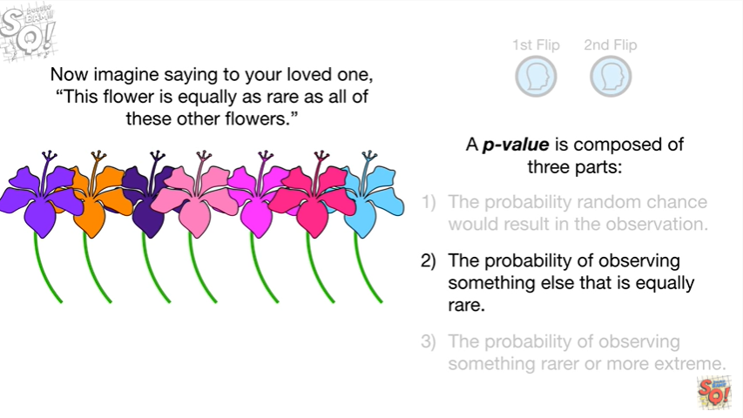

Now imagine saying to your loved one this flower is equally as rare as all of these other flowers.

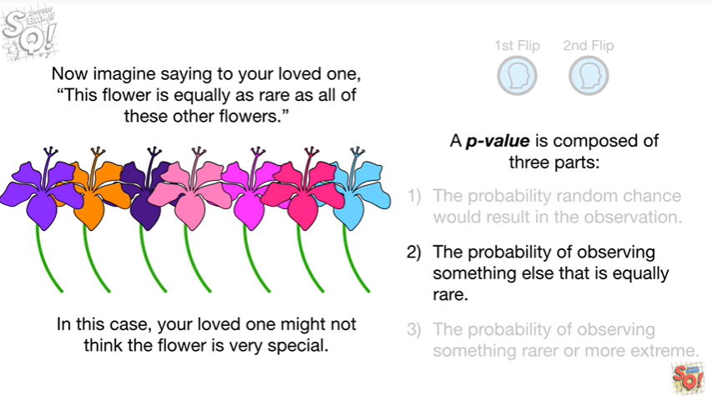

In this case your loved one might not think the flower is very special.

Wha-wha.

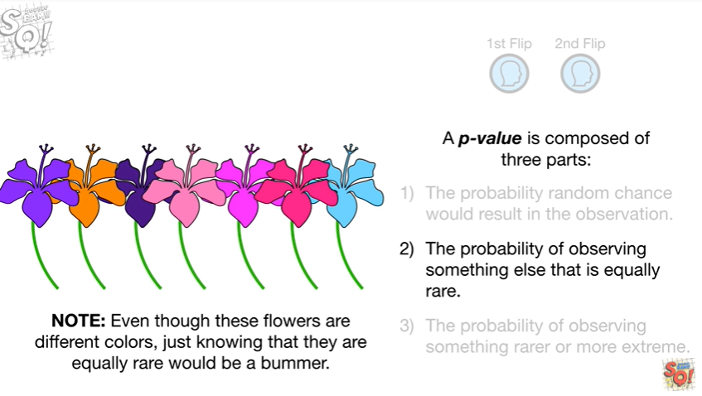

Note : even though these flowers are different colors just knowing that they're equally rare would be a bummer.

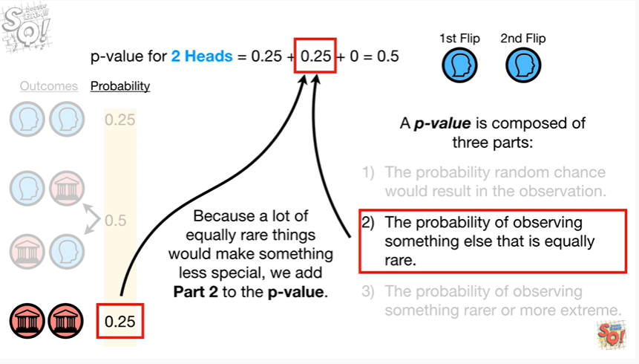

Because a lot of equally rare things would make something less special we add part two to the p-value.

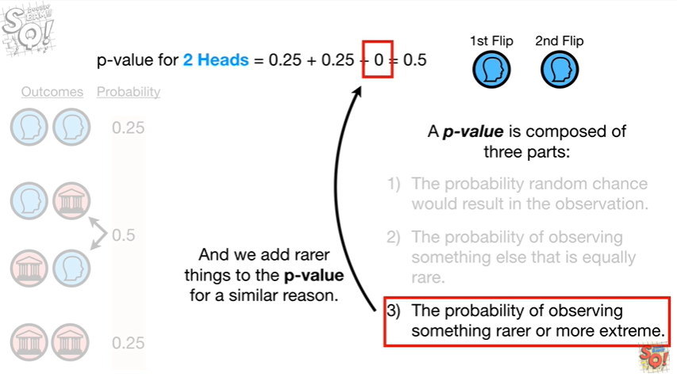

And we add rare things to the p-value for a similar reason.

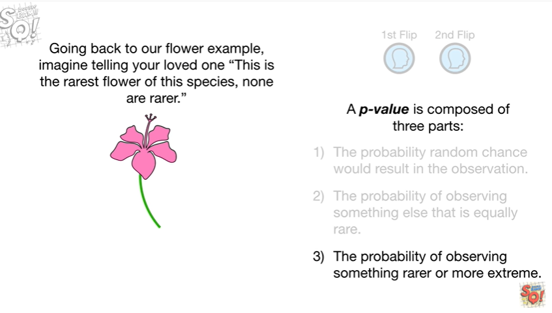

Going back to our flower example imagine telling your loved one this is the rarest flower of this species none are rarer.

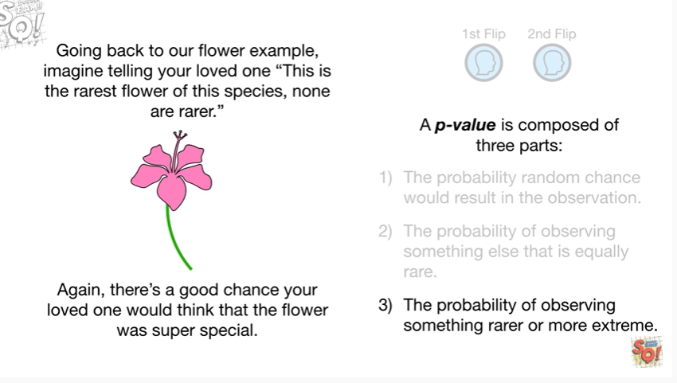

Again there's a good chance your loved one would think that the flower was super special.

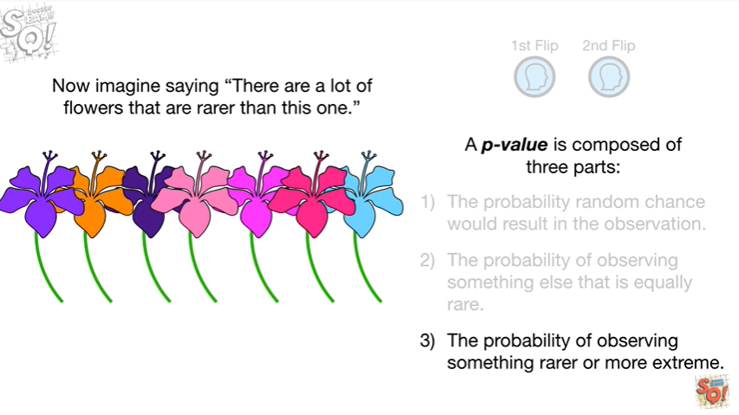

Now imagine saying there are a lot of flowers that are rarer than this one.

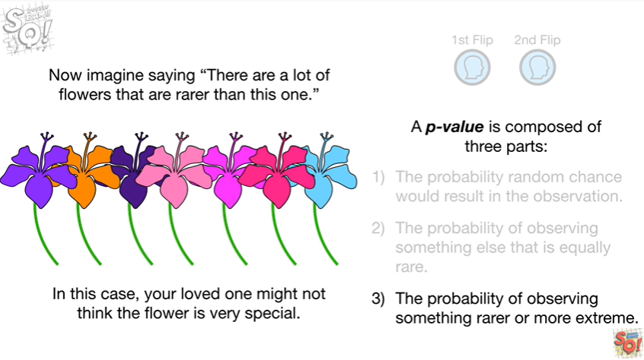

In this case your loved one might not think the flower is very special.

Wah-wah.

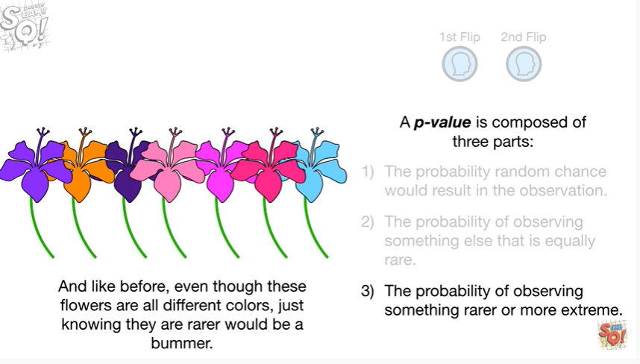

And like before even though these flowers are all different colors just knowing they are rare would be a bummer.

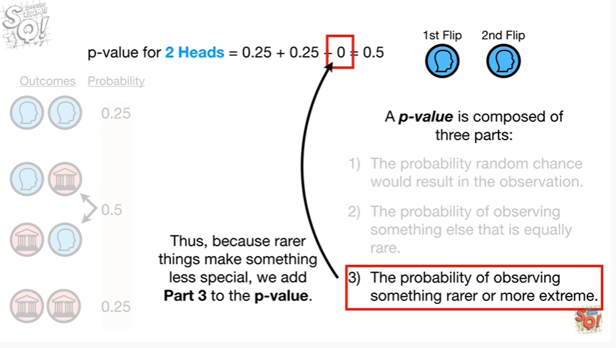

Thus because rarer things make something less special we add part three to the p-value.

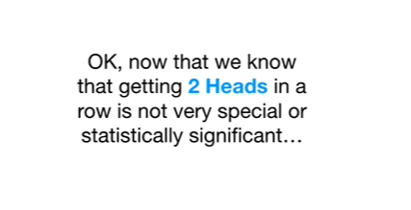

Okay now that we know that getting two heads in a row is not very special or statistically significant

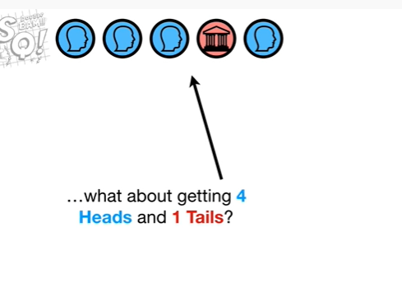

what about getting four heads and one tails ?

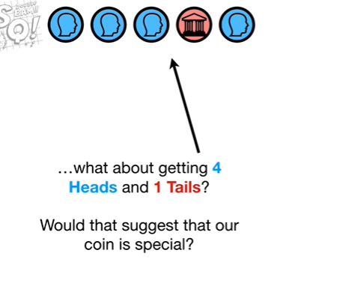

Would that suggest that our coin is special ?

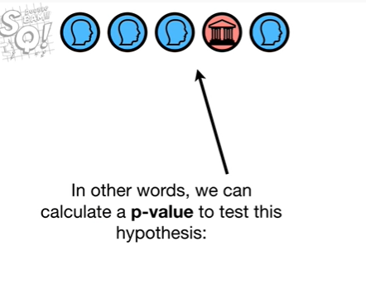

In other words we can calculate a p-value to test this hypothesis :

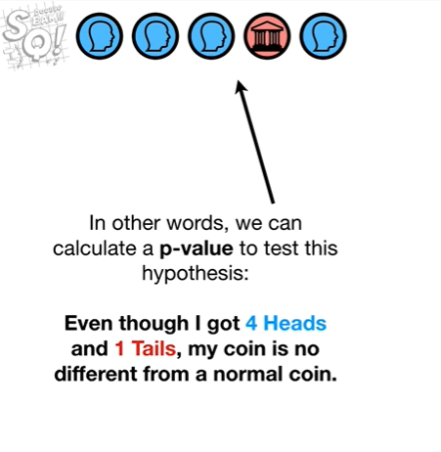

even though I got four heads and one tails, my coin is no different from a normal coin.

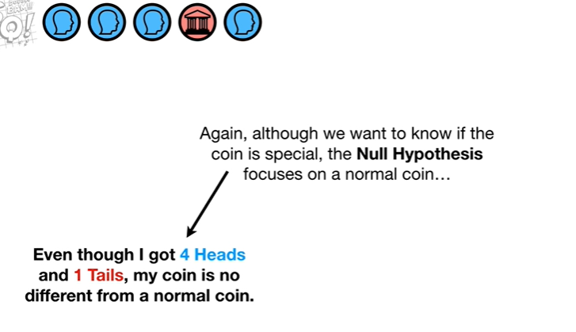

Again although we want to know if the coin is special the null hypothesis focuses on a normal coin

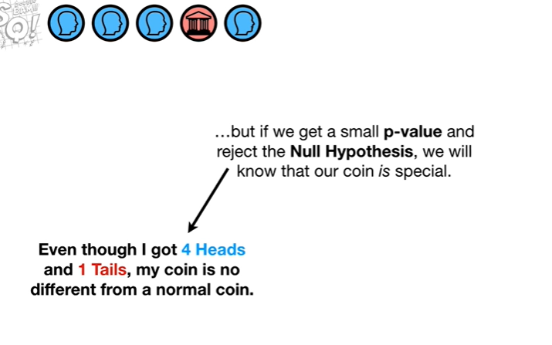

but if we get a small p-value and reject the null hypothesis we will know that our coin is special.

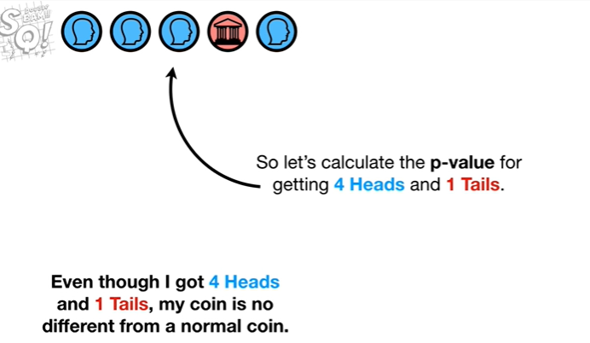

So let's calculate the p-value for getting four heads and one tail.



First we know that it is possible to flip a coin five times and get heads each time

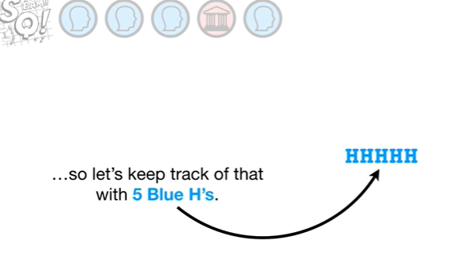

so let's keep track of that with five blue H's.

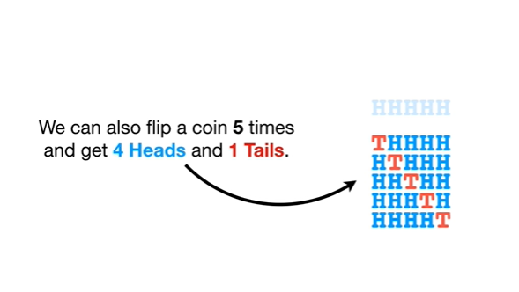

We can also flip a coin five times and get four heads and one tails.

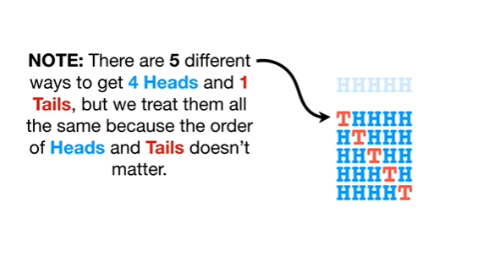

Note : there are five different ways to get four heads and one tails but we treat them all the same because the order of heads and tails doesn't matter.

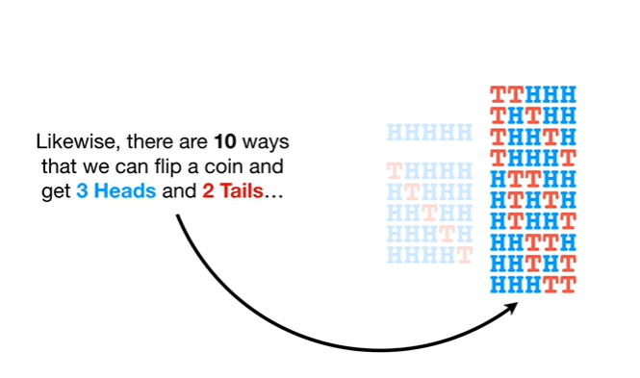

Likewise there are ten ways that we can flip a coin and get three heads and two tails

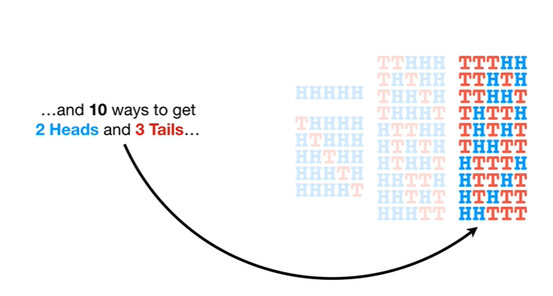

and ten ways to get two heads and three tails

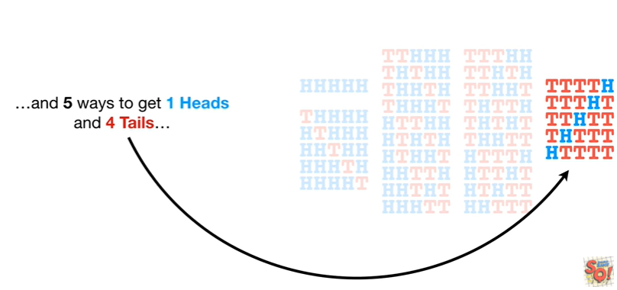

and five ways to get one heads and four tails

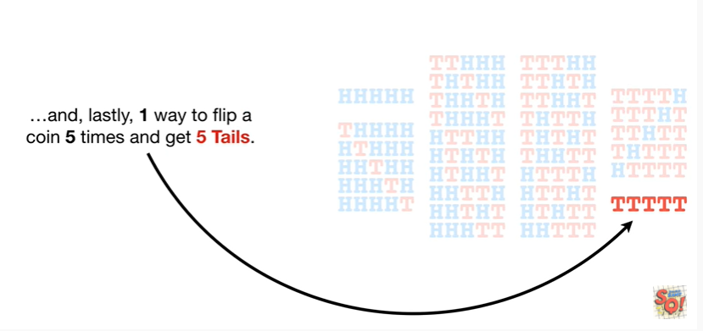

and lastly one way to flip a coin five times and get five tails.

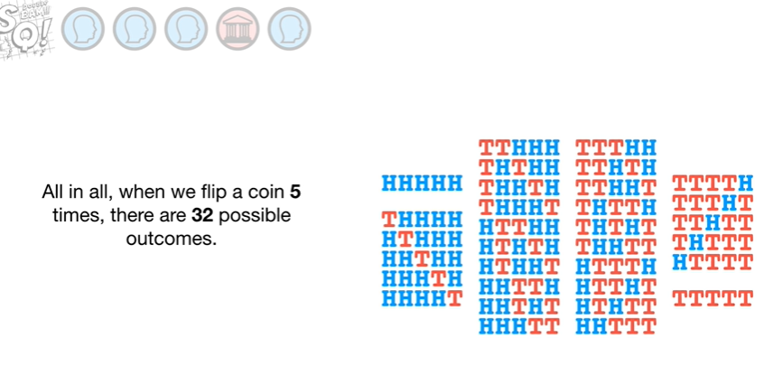

All in all when we flip a coin five times there are 32 possible outcomes.

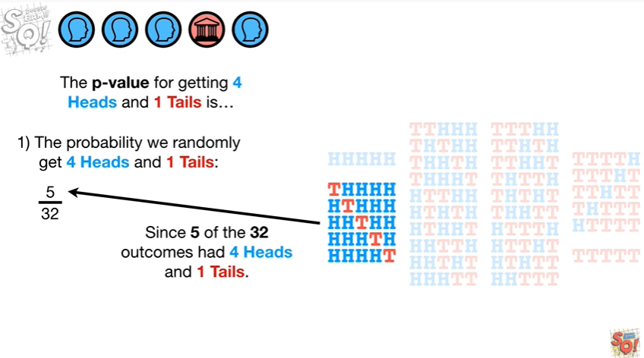

The p-value for getting four heads and one tails is

1. the probability we randomly get four heads and one tails this is 5/32.

Since five of the 32 outcomes had four heads and one tails.

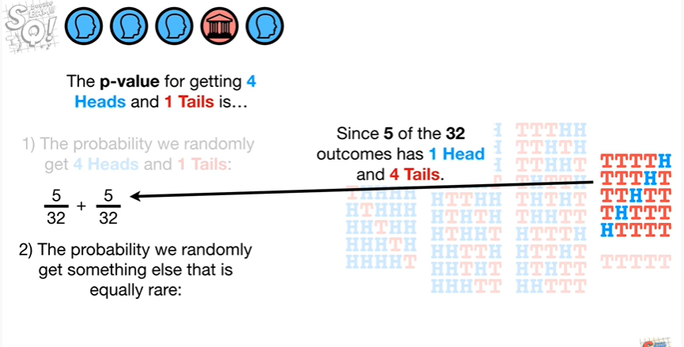

2. the probability we randomly get something else that is equally rare : this is 5 divided by 32 since 5 of the 32 outcomes had one head and four tails

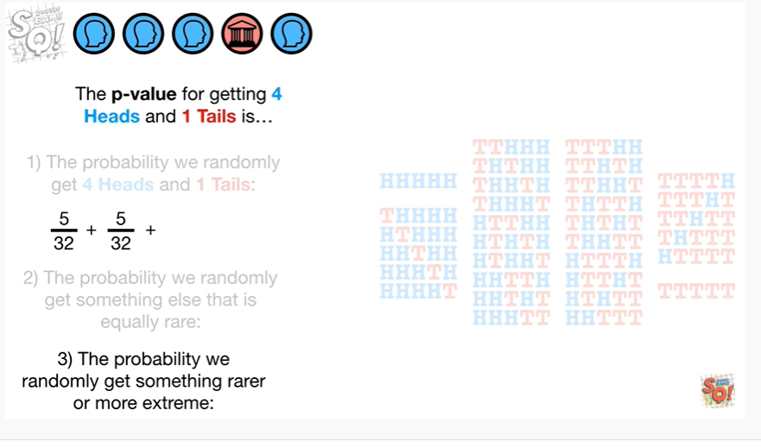

3. the probability we randomly get something rarer or more extreme this is 2 divided by 32

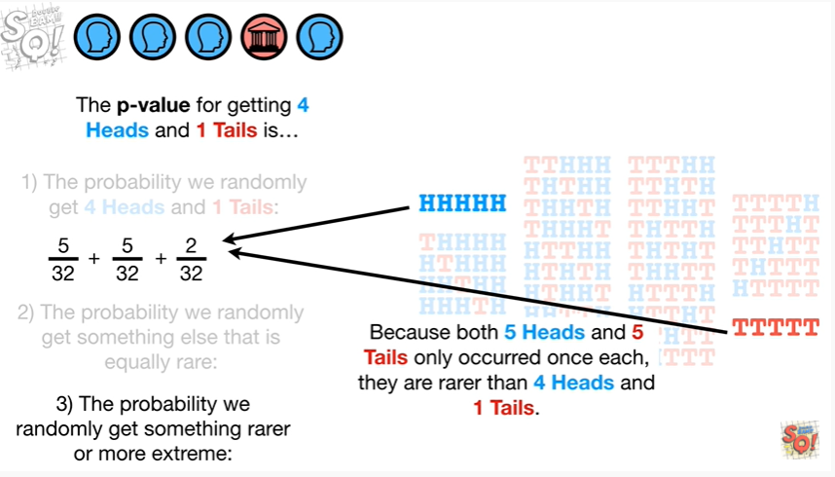

Because both 5 heads and 5 tails only occurred once each they are rarer than four heads and one tails.

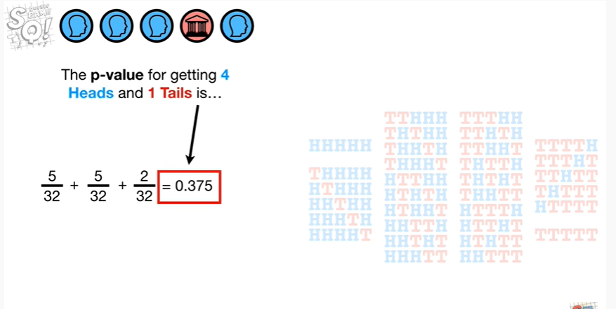

Thus the p-value for getting four heads and one tails is 0.375.

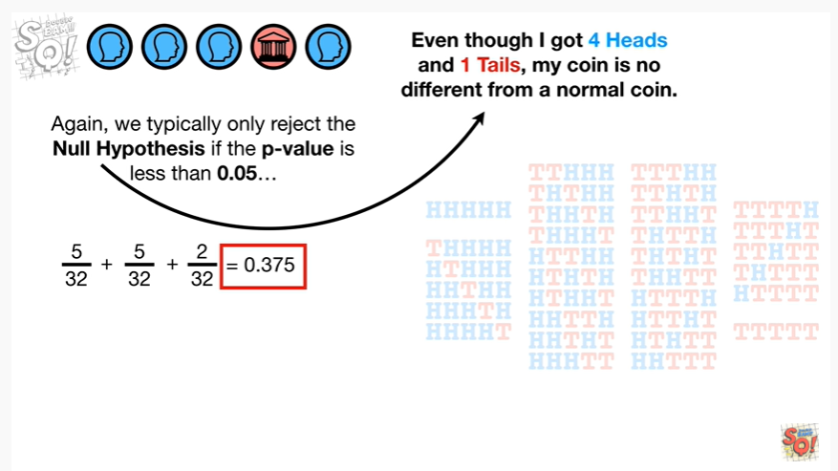

Again we typically only reject the null hypothesis if the p-value is less than 0.05

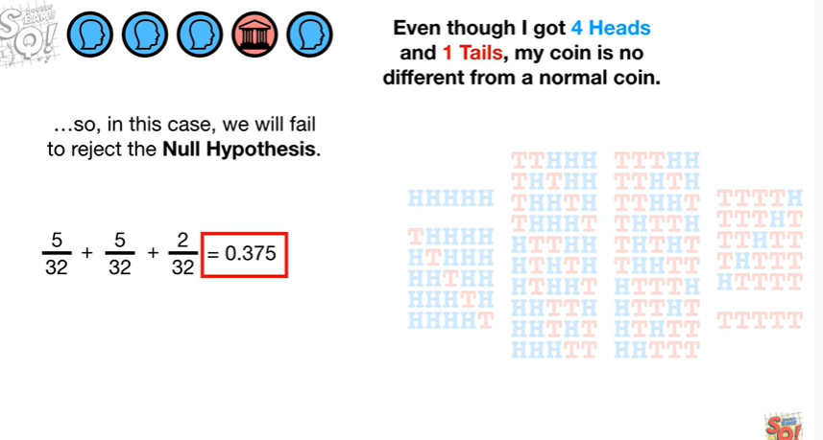

so in this case we will fail to reject the null hypothesis.

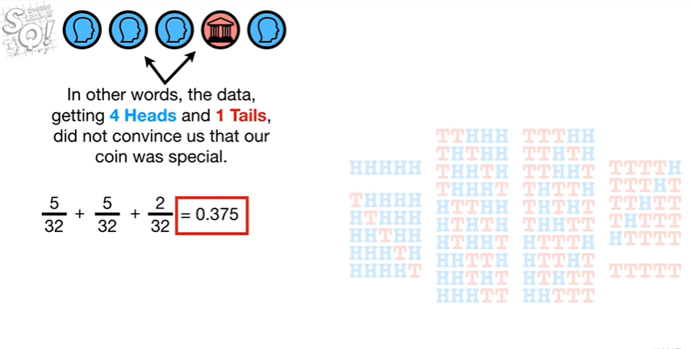

In other words the data getting four heads and one tails did not convince us that our coin was special.

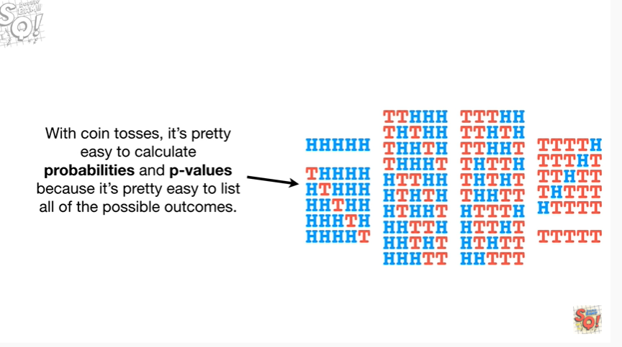

With coin tosses it's pretty easy to calculate probabilities and p-values because it's pretty easy to list all of the possible outcomes.

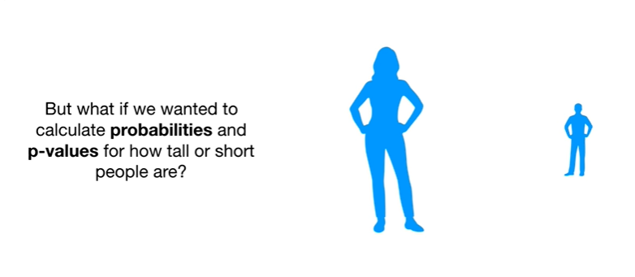

But what if we wanted to calculate probabilities and p-values for how tall or short people are ?

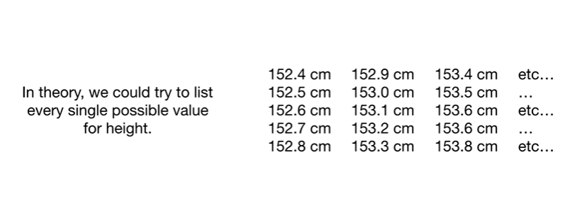

In theory we could try to list every single possible value for height.

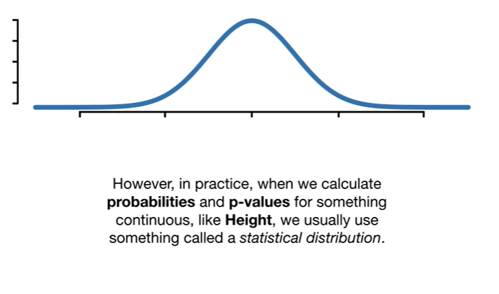

However in practice when we calculate probabilities and p-values for something continuous like height we usually use something called a statistical distribution.

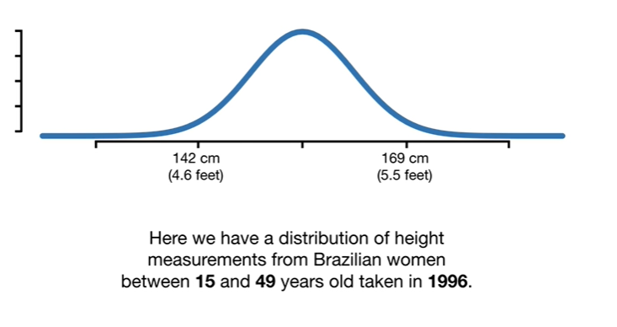

Here we have a distribution of height measurements from Brazilian women between 15 and 49 years old taken in 1996.

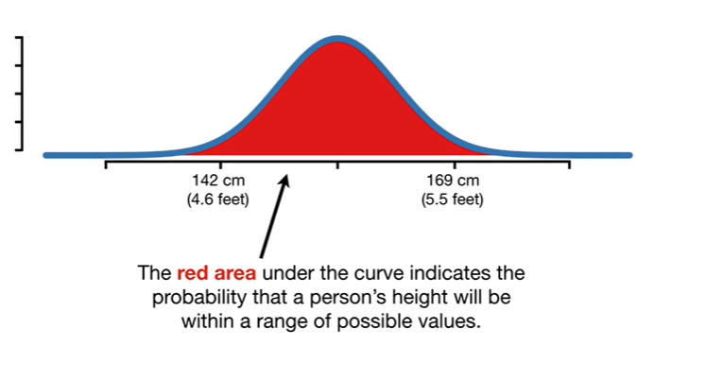

The red area under the curve indicates the probability that a person's height will be within a range of possible values.

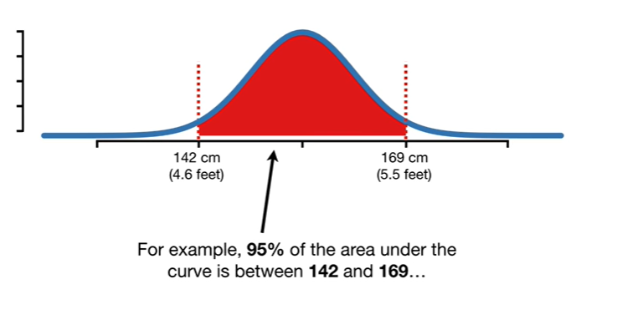

For example 95 percent of the area under the curve is between 142 and 169

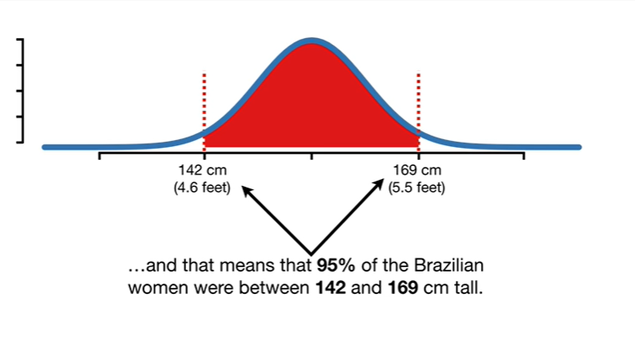

and that means that 95 percent of the Brazilian women were between 142 and 169 centimeters tall.

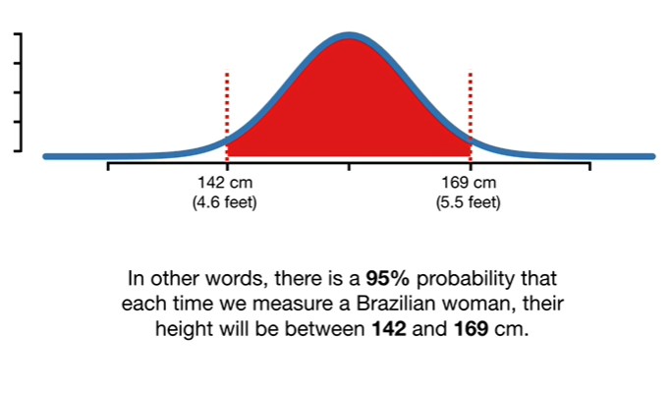

In other words there is a 95 percent probability that each time we measure a Brazilian woman their height will be between 142 and 169 centimeters.

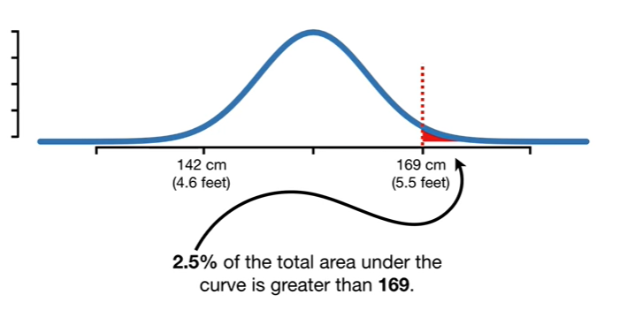

2.5 percent of the total area under the curve is greater than 169.

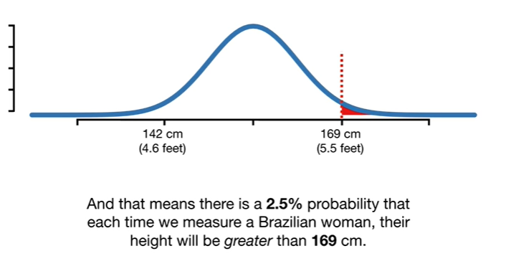

And that means there is a 2.5 percent probability that each time we measure a Brazilian woman their height will be greater than 169 centimeters.

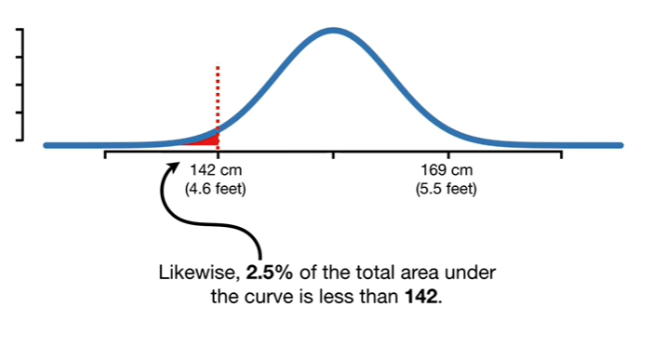

Likewise 2.5 percent of the total area under the curve is less than 142.

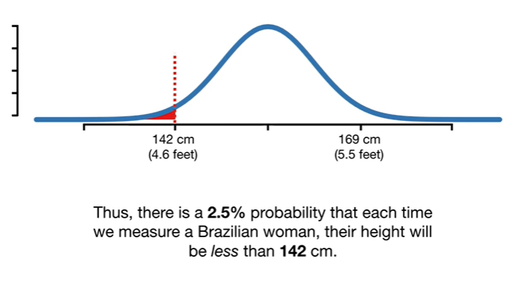

Thus there is a 2.5 percent probability that each time we measure a Brazilian woman their height will be less than 142 centimeters.

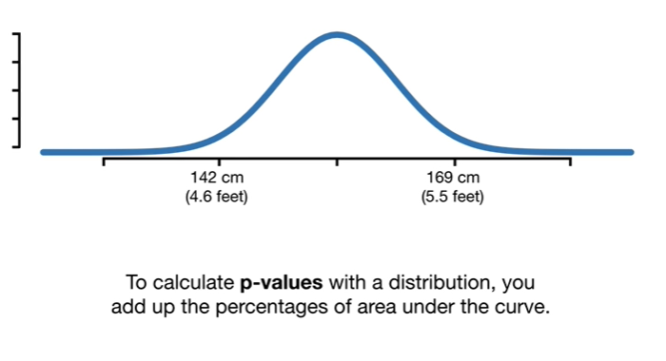

To calculate p-values with a distribution you add up the percentages of area under the curve.

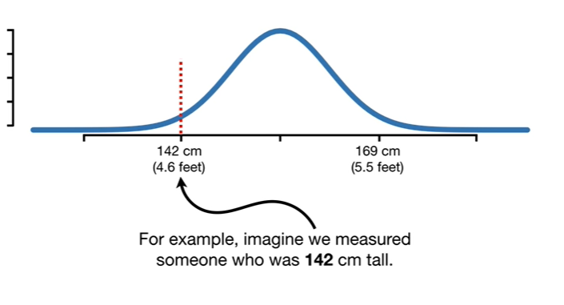

For example imagine we measured someone who is 142 centimeters tall.

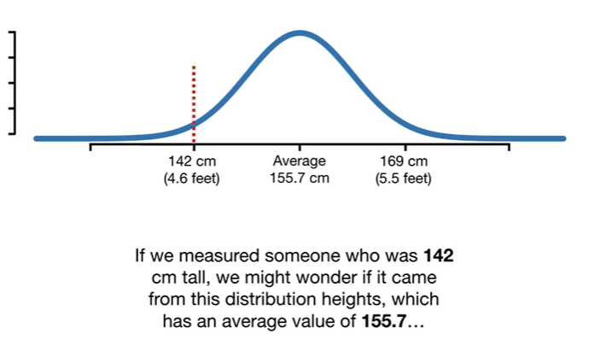

If we measured someone who is 142 centimeters tall we might wonder if it came from this distribution of heights which has an average value of 155.7

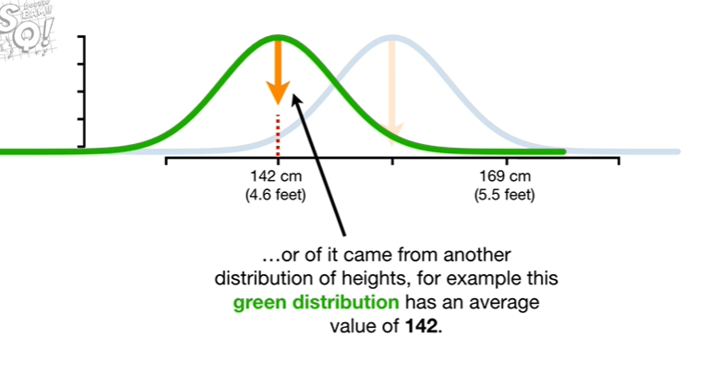

or if it came from another distribution of heights for example this green distribution has an average value of 142.

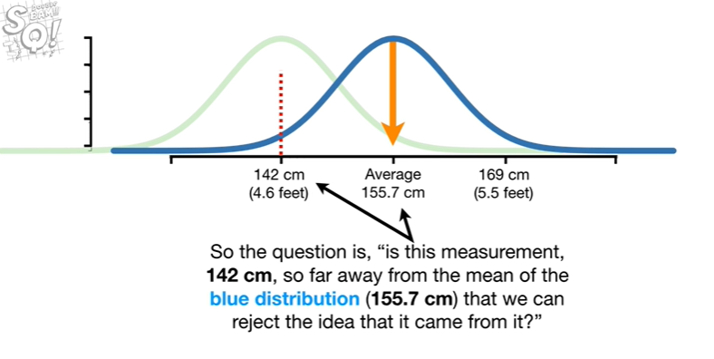

So the question is is this measurement 142 centimeters so far away from the mean of the blue distribution that we can reject the idea that it came from it ?

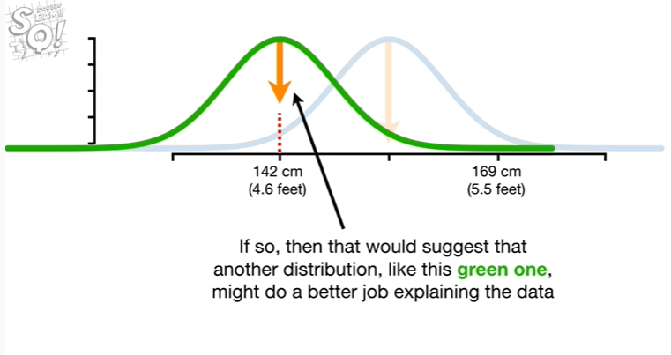

If so then that would suggest that another distribution like this green one might do a better job explaining the data.

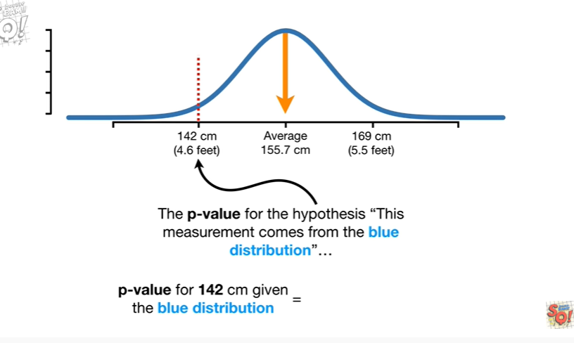

The p-value for the hypothesis this measurement comes from the blue distribution

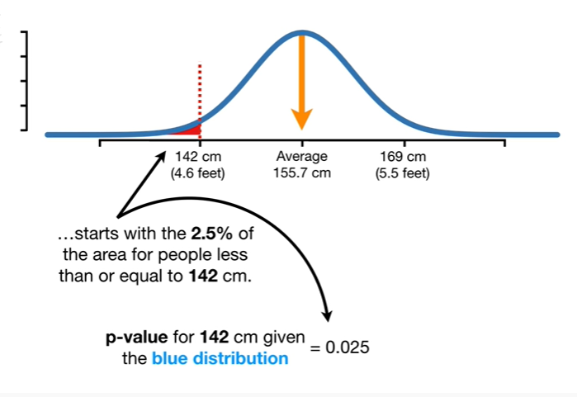

starts with the 2.5 percent of the area for people less than or equal to 142 centimeters.

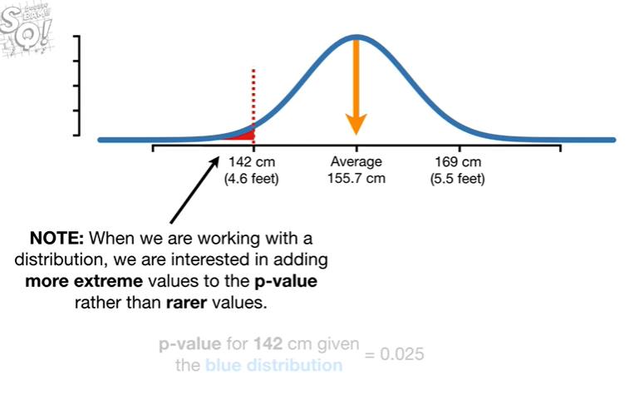

Note : when we are working with a distribution we are interested in adding more extreme values to the p value rather than rarer values.

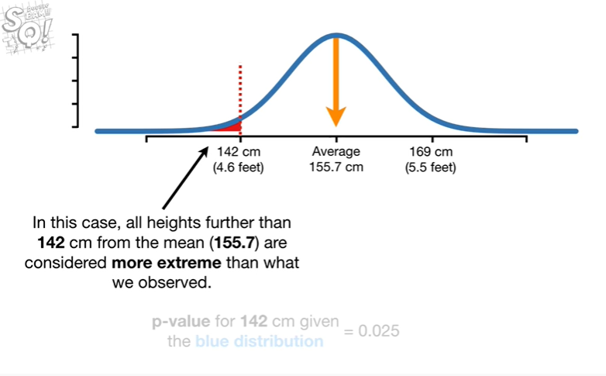

In this case all heights further than 142 centimeters from the mean are considered more extreme than what we observed.

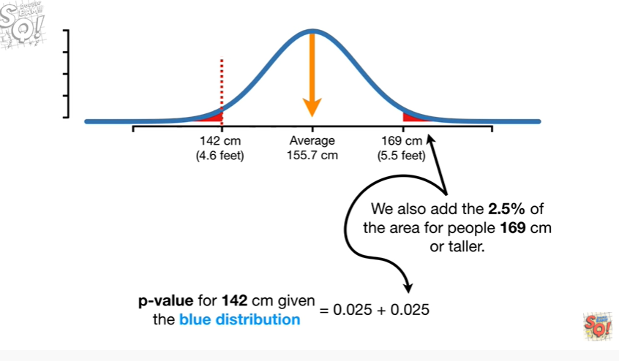

We also add the 2.5% of the area for people 169 centimeters or taller.

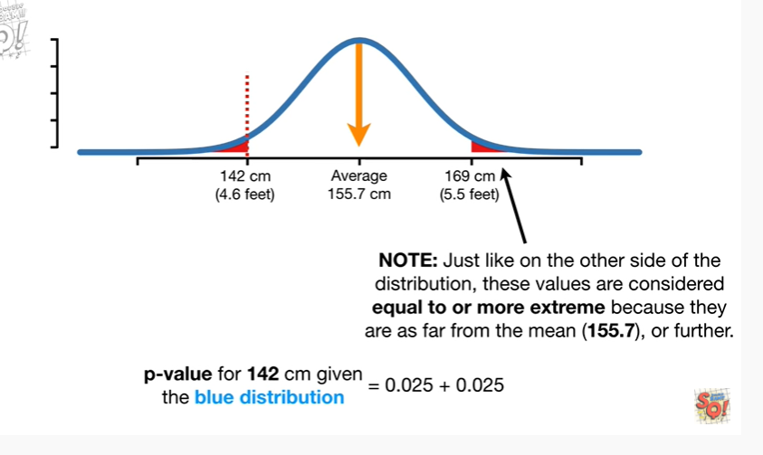

Note : just like on the other side of the distribution these values are considered equal to or more extreme because there is far from the mean or further.

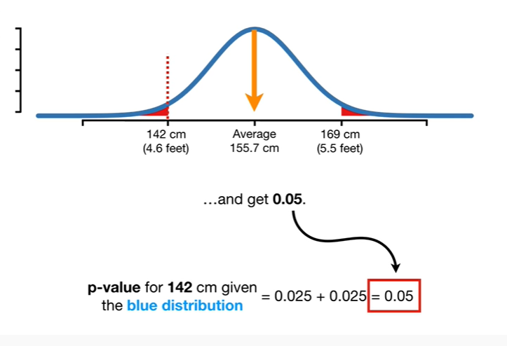

Now we just do the math and get 0.05.

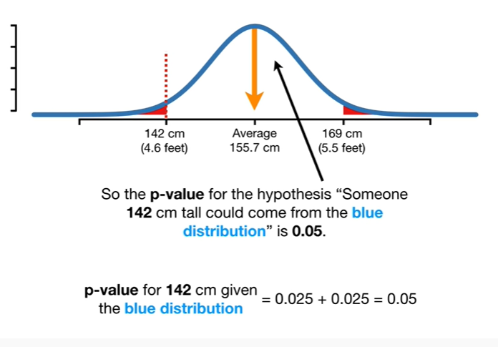

So the p-value for the hypothesis someone 142 centimeters tall could come from the blue distribution is 0.05.

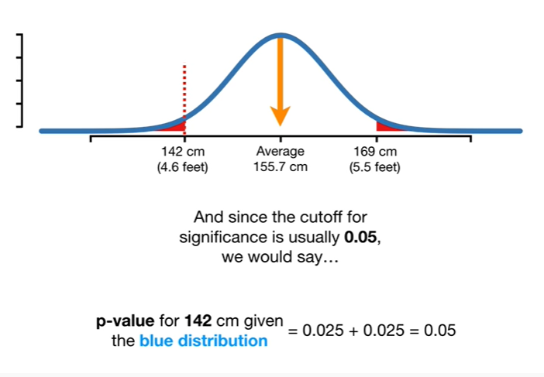

And since the cutoff for significance is usually 0.05 we would say

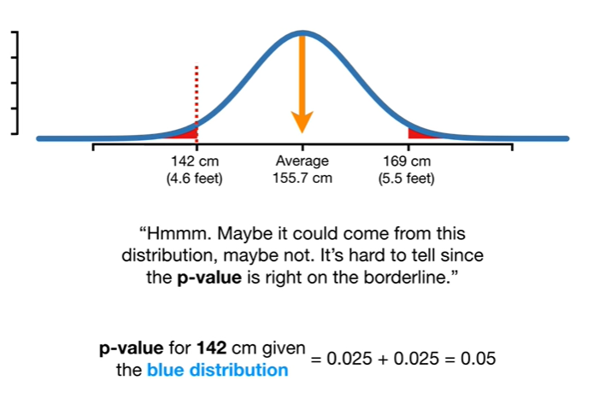

Hmm.

Maybe it could come from this distribution maybe not.

It's hard to tell since the p-value is right on the borderline.

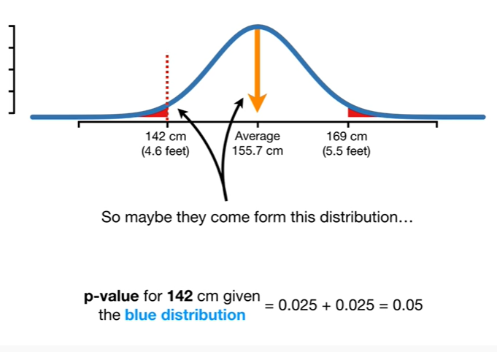

So maybe they come from this distribution

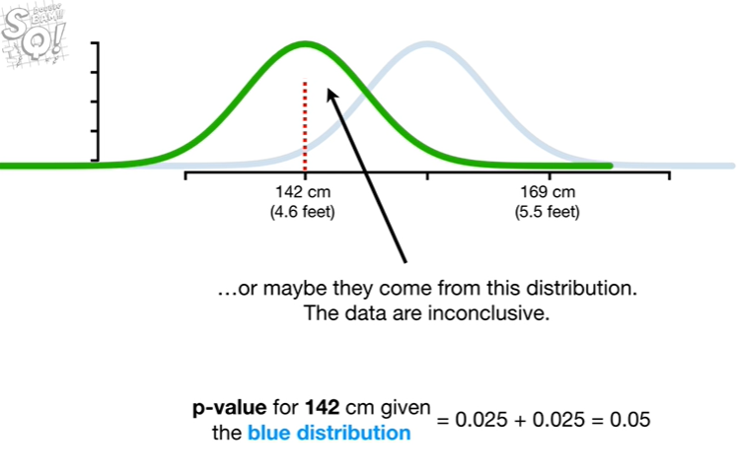

or maybe they come from this distribution.

The data are inconclusive.

Wah wah.

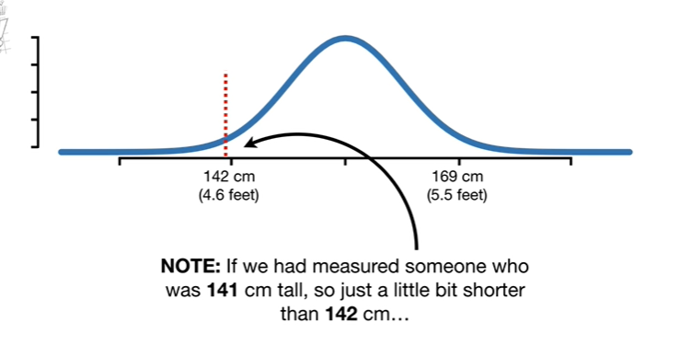

Note : if we had measured someone who is 141 centimeters tall so just a little bit shorter than 142 centimeters

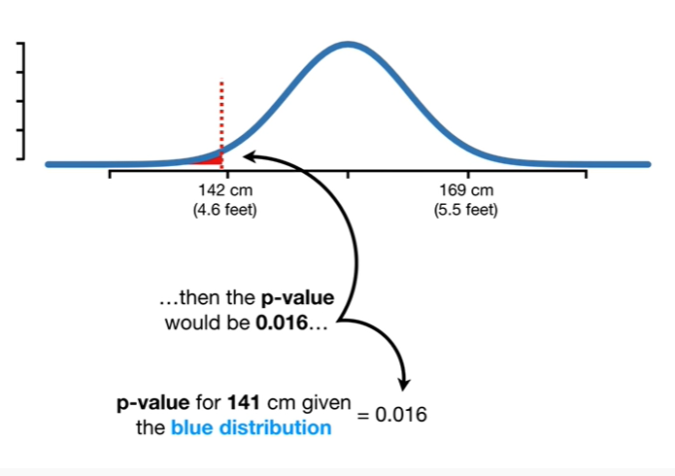

then the p value would be 0.01 6

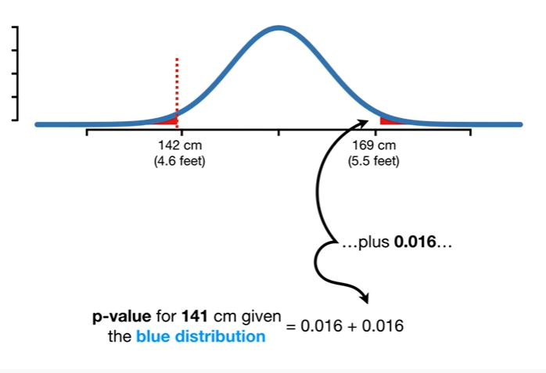

plus 0.01 6

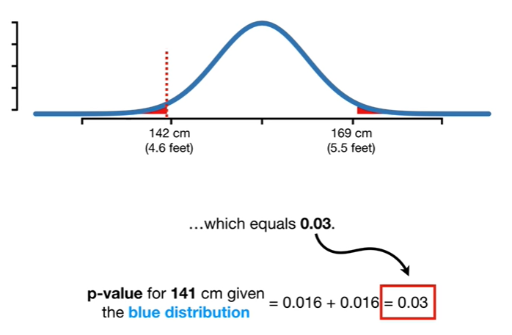

which equals zero point zero three

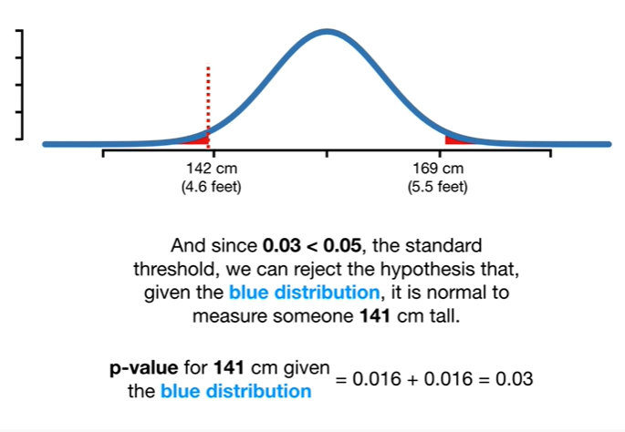

and since 0.03 is less than 0.05 the standard threshold we can reject the hypothesis that given the blue distribution it is normal to measure someone 141 centimeters tall.

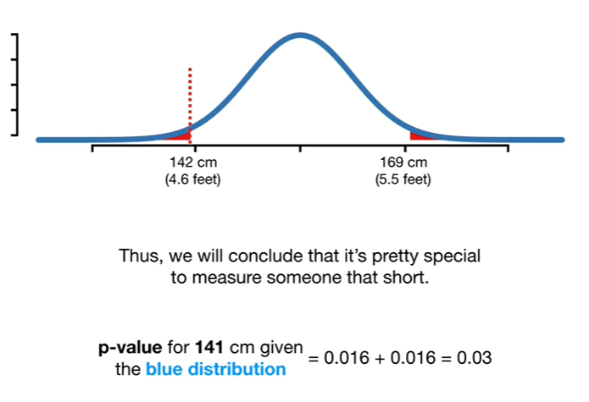

Thus we will conclude that it's pretty special to measure someone that short.

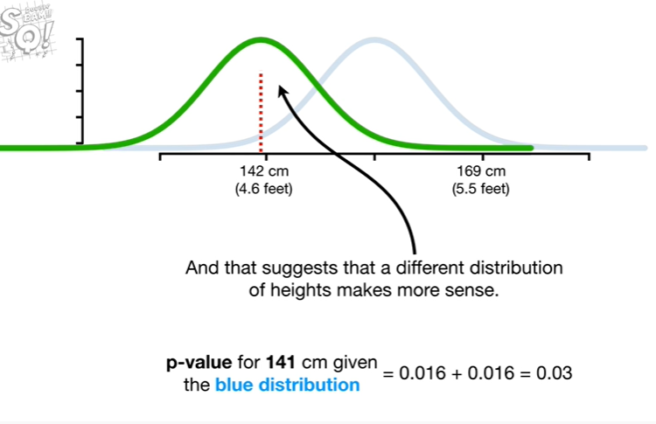

And that suggests that a different distribution of Heights makes more sense.

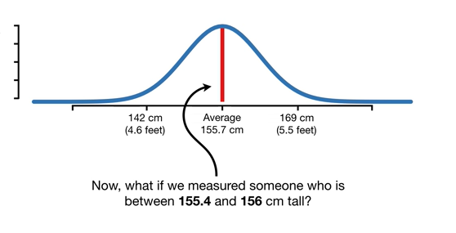

Now what if we measured someone who is between 155 point four in 156 centimeters tall ?

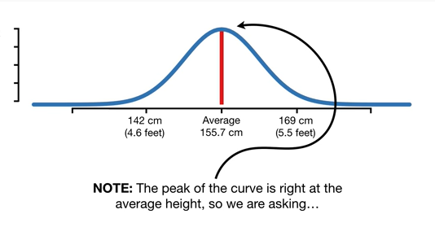

Note : the peak of the curve is right at the average height so we were asking

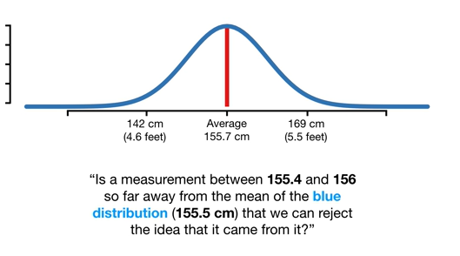

is a measurement between 155 point four and 156 so far away from the mean of the blue distribution that we can reject the idea that it came from it ?

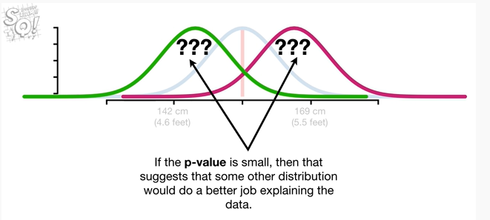

If the p-value is small then that suggests that some other distribution would do a better job explaining the data.

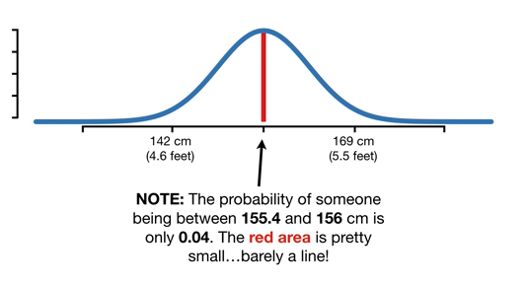

Note : the probability of someone being between 155 point four and 156 centimeters is only 0.04 the red area is pretty small barely a line !

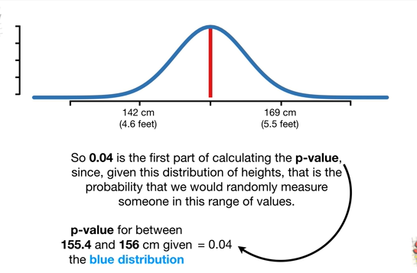

So 0.04 is the first part of calculating the p-value since given this distribution of heights that is the probability that we would randomly measure someone in this range of values.

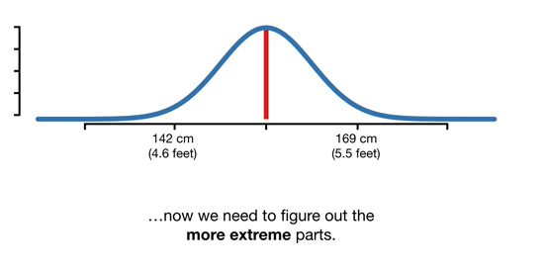

Now we need to figure out the more extreme parts.

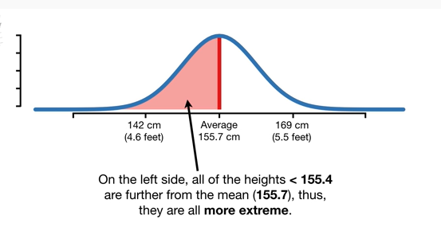

On the left side all of the heights less than 150 5.4 are further from the mean thus they are more extreme.

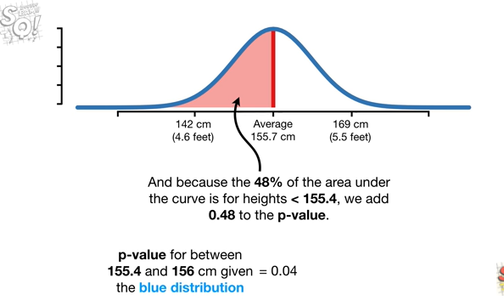

And because 48% of the area under the curve is for Heights less than 150 5.4 we add 0.48 to the p-value.

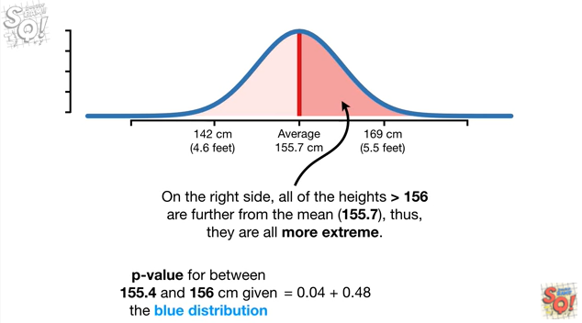

On the right side all of the heights greater than 156 are further from the mean thus they are all more extreme.

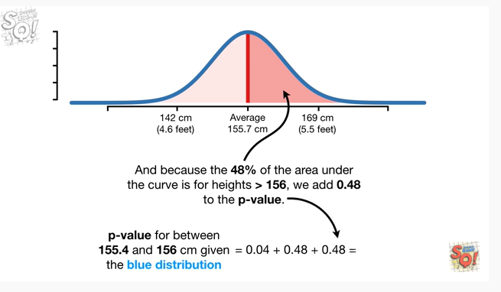

And because 48% of the area under the curve is for Heights greater than 156 we add 0.48 to the p-value.

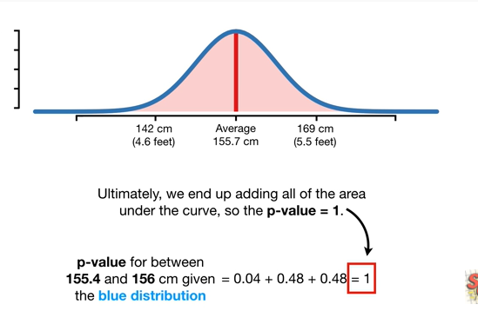

Ultimately we end up adding all of the area under the curve so the p-value equals one.

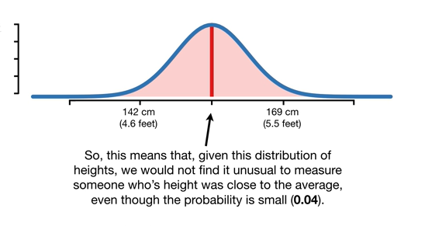

So this means that given this distribution of heights we would not find it unusual to measure someone whose height was close to the average even though the probability is small (0.04).

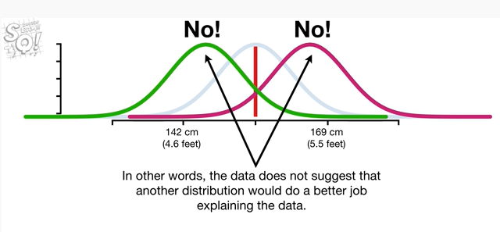

In other words, the data does not suggest that another distribution would do a better job explaining the data.

BAM.

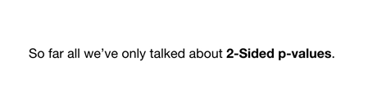

So far we've only talked about two-sided p-values.



Now I'll give you an example of a one-sided p-value and tell you why it has the potential to be dangerous.

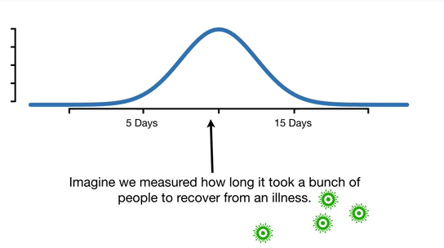

Imagine we measured how long it took a bunch of people to recover from an illness.

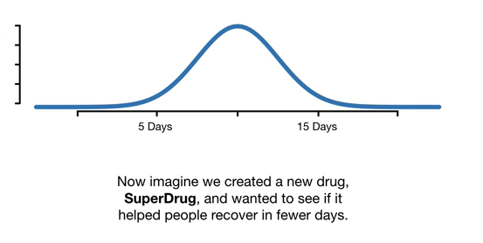

Now imagine we created a new drug super drug and wanted to see if it helped people recover in fewer days.

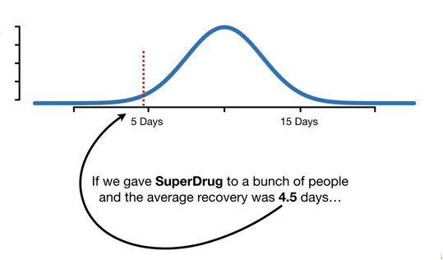

If we gave super drug to a bunch of people and the average recovery was 4.5 days

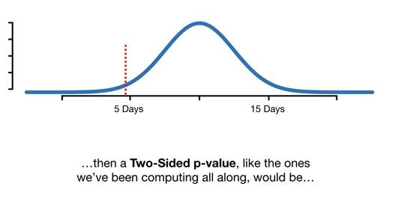

then a two-sided p-value like the ones we've been computing all along would be

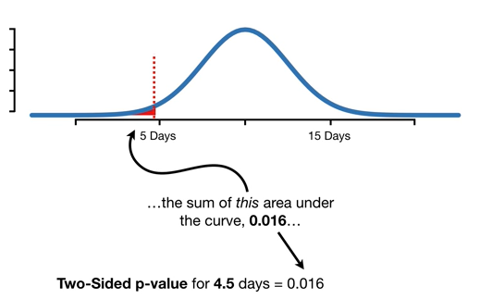

the sum of this area under the curve 0.016

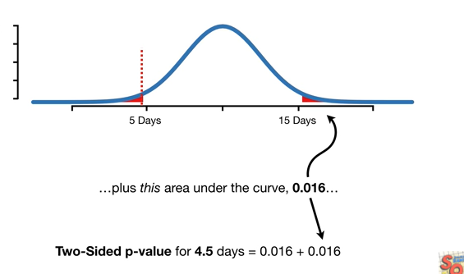

plus this area under the curve 0.016

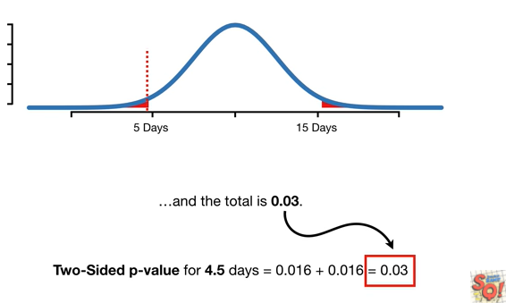

and the total is 0.03.

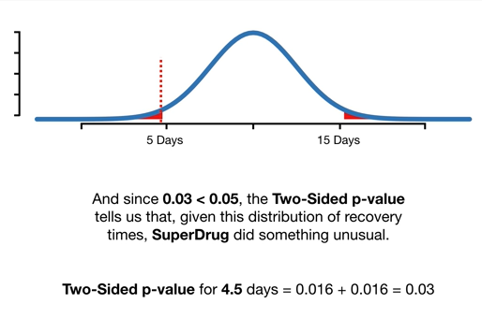

And since 0.03 is less than 0.05 the two-sided p-value tells us that given this distribution of recovery times super drug did something unusual.

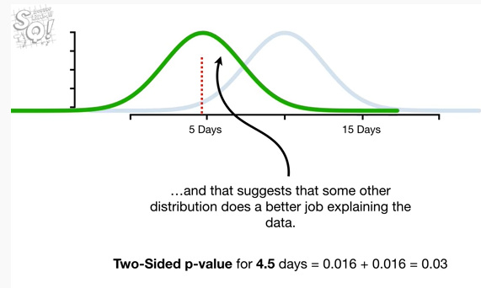

and that suggests that some other distribution does a better job explaining the data.

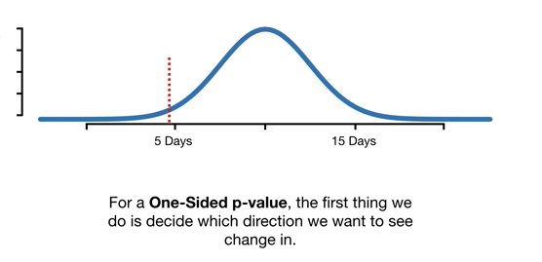

For a one-sided p-value the first thing we do is decide which direction we want to see change in.

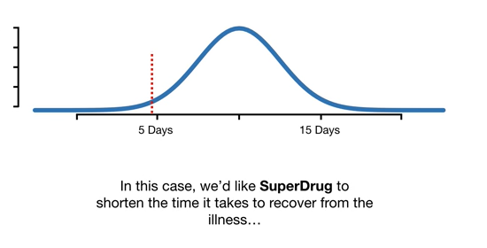

In this case we'd like super drug to shorten the time it takes to recover from the illness

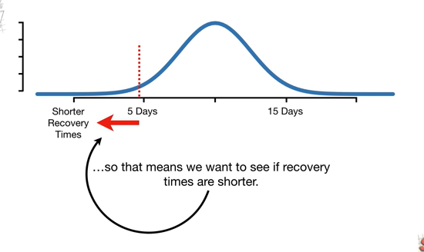

so that means we want to see if recovery times are shorter.

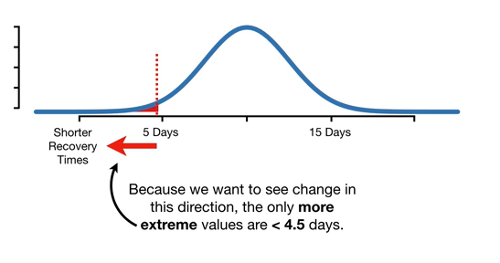

Because we want to see change in this direction the only more extreme values are less than 4.5 days.

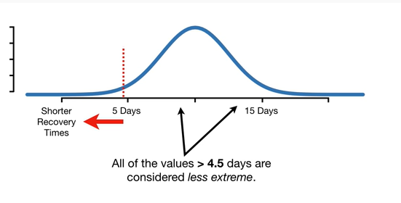

All of the values greater than 4.5 days are considered less extreme.

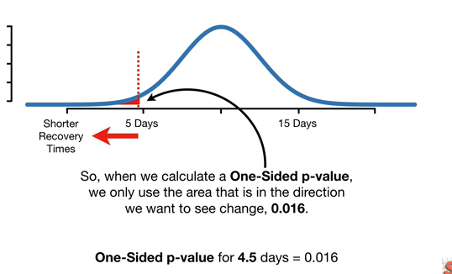

So when we calculate a one-sided p-value we only use the area that is in the direction we want to see change 0.016.

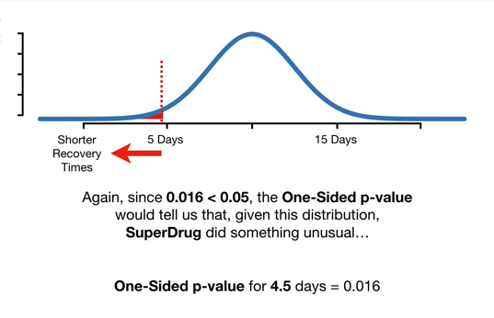

Again since 0.01 6 is less than 0.05 the one-sided p-value would tell us that given this distribution super drug did something unusual

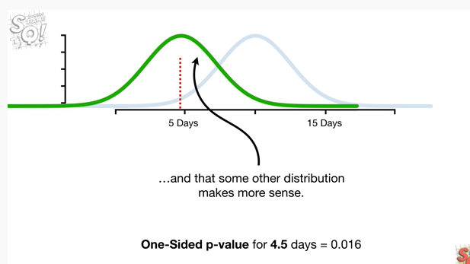

and that some other distribution makes more sense.

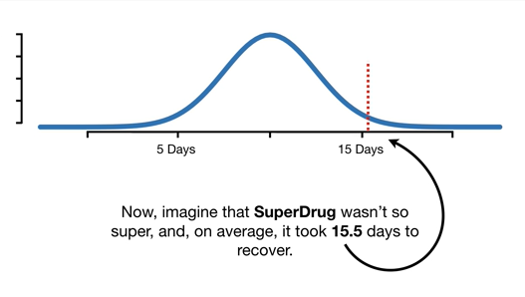

Now imagine that super drug wasn't so super and on average it took fifteen point five days to recover.

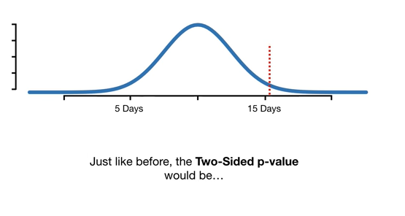

Just like before the two-sided p-value would be

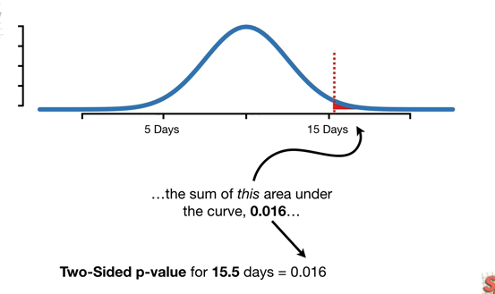

the sum of this area under the curve zero point zero one six

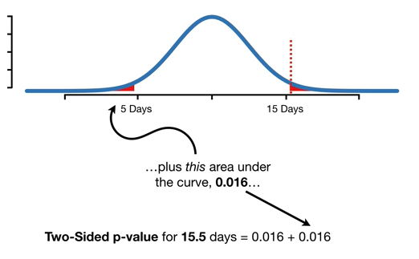

plus this area under the curve zero point zero one six

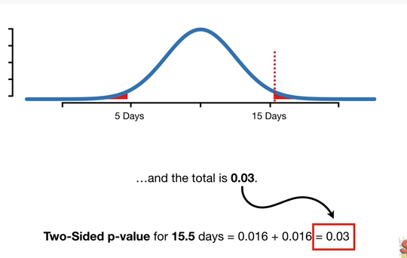

and the total is zero point zero three.

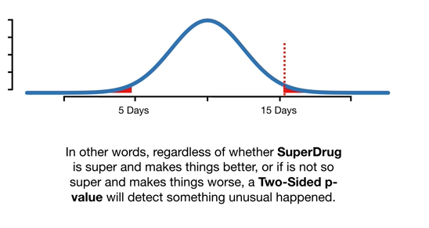

In other words regardless of whether super drug is super and makes things better or if it is not so super and makes things worse a two-sided p-value will detect something unusual happened.

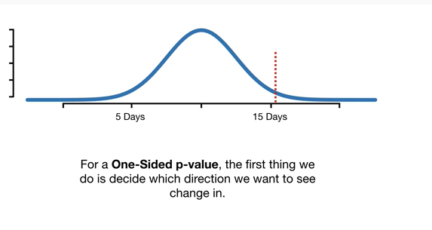

For a one-sided p-value the first thing we do is decide which direction we want to see change in.

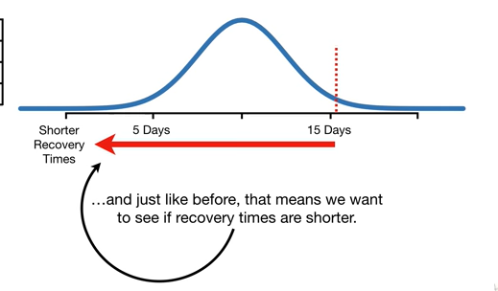

And just like before that means we want to see if recovery times are shorter.

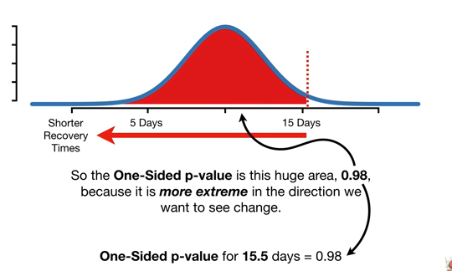

So the one-sided p-value is this huge area 0.98 because it is more extreme in the direction we want to see change.

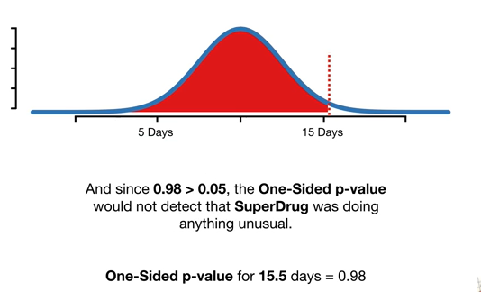

And since 0.98 is greater than 0.05 the one-sided p-value would not detect that Superdrug was doing anything unusual.

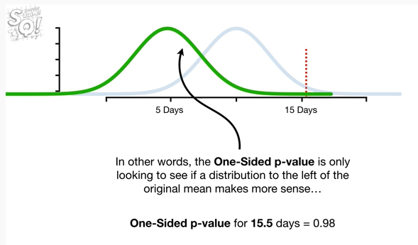

In other words the one-sided p-value is only looking to see if a distribution to the left of the original mean makes more sense

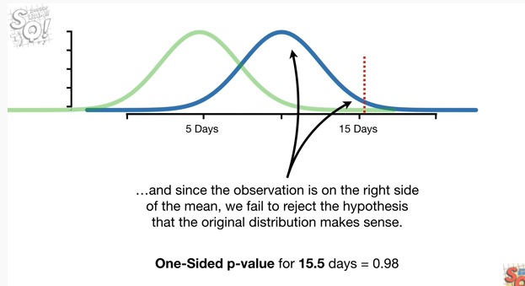

and since the observation is on the right side of the mean we fail to reject the hypothesis that the original distribution makes sense

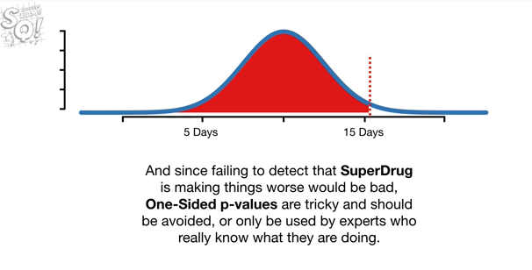

and since failing to detect that Superdrug is making things worse would be bad one-sided p-values are tricky and should be avoided or only used by experts who really know what they're doing.

BAM !!

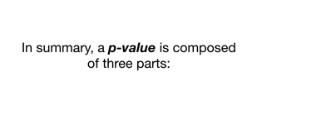

In summary a p-value is composed of three parts :

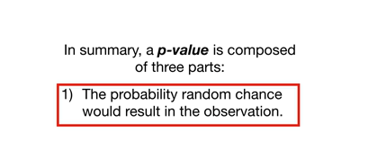

the first part is the probability random chance would result in the observation

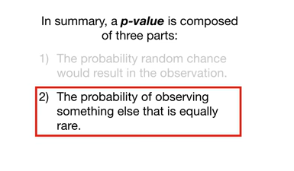

the second part is the probability of observing something else that is equally rare

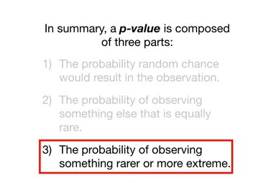

and the third part is the probability of observing something rarer or more extreme.

BAM !!!